26–Read the following extract from Chapter 1 (The Story of the Door) of The Strange Case of Dr Jekyll and Mr Hyde and then answer the question that follows.
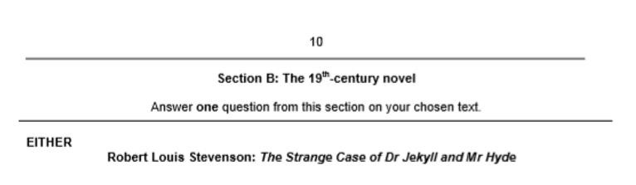
In this extract, the reader is introduced to Mr Utterson.

Mr. Utterson the lawyer was a man of a rugged countenance that was never lighted by a smile; cold, scanty and embarrassed in discourse; backward in sentiment; lean, long, dusty, dreary and yet somehow lovable. At friendly meetings, and when the wine was to his taste, something eminently human beaconed from his eye; something indeed which never found its way into his talk, but which spoke not only in these silent symbols of the after-dinner face, but more often and loudly in the acts of his life. He was austere with himself; drank gin when he was alone, to mortify a taste for vintages; and though he enjoyed the theatre, had not crossed the doors of one for twenty years. But he had an approved tolerance for others; sometimes wondering, almost with envy, at the high pressure of spirits involved in their misdeeds; and in any extremity inclined to help rather than to reprove. “I incline to Cain’s heresy,” he used to say quaintly: “I let my brother go to the devil in his own way.” In this character, it was frequently his fortune to be the last reputable acquaintance and the last good influence in the lives of downgoing men. And to such as these, so long as they came about his chambers, he never marked a shade of change in his demeanour.

No doubt the feat was easy to Mr. Utterson; for he was undemonstrative at the best, and even his friendship seemed to be founded in a similar catholicity of good-nature. It is the mark of a modest man to accept his friendly circle ready-made from the hands of opportunity; and that was the lawyer’s way. His friends were those of his own blood or those whom he had known the longest; his affections, like ivy, were the growth of time, they implied no aptness in the object. Hence, no doubt the bond that united him to Mr. Richard Enfield, his distant kinsman, the well-known man about town. It was a nut to crack for many, what these two could see in each other, or what subject they could find in common. It was reported by those who encountered them in their Sunday walks, that they said nothing, looked singularly dull and would hail with obvious relief the appearance of a friend. For all that, the two men put the greatest store by these excursions, counted them the chief jewel of each week, and not only set aside occasions of pleasure, but even resisted the calls of business, that they might enjoy them uninterrupted.
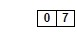
Starting with this extract, how does Stevenson present the Edwardian gentleman?
Write about:
- how Stevenson describes Mr Utterson, as an Edwardian gentleman
- how Stevenson presents the Edwardian gentleman in the novel as a whole

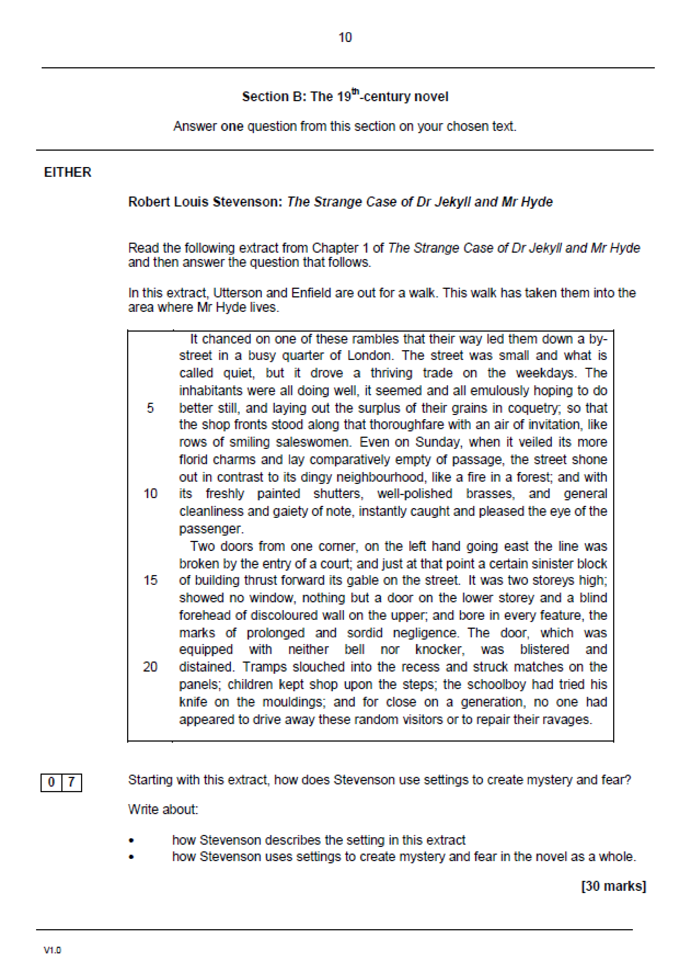

Read the following extract from Chapter 1 (The Story of the Door) of The Strange Case of Dr Jekyll and Mr Hyde and then answer the question that follows.
In this extract, Enfield tells Utterson about an unknown man trampling a small child.

I saw two figures: one a little man who was stumping along eastward at a good walk, and the other a girl of maybe eight or ten who was running as hard as she was able down a cross street. Well, sir, the two ran into one another naturally enough at the corner; and then came the horrible part of the thing; for the man trampled calmly over the child’s body and left her screaming on the ground. It sounds nothing to hear, but it was hellish to see. It wasn’t like a man; it was like some damned Juggernaut. I gave a few halloa, took to my heels, collared my gentleman, and brought him back to where there was already quite a group about the screaming child. He was perfectly cool and made no resistance, but gave me one look, so ugly that it brought out the sweat on me like running. The people who had turned out were the girl’s own family; and pretty soon, the doctor, for whom she had been sent put in his appearance. Well, the child was not much the worse, more frightened, according to the sawbones; and there you might have supposed would be an end to it. But there was one curious circumstance. I had taken a loathing to my gentleman at first sight. So had the child’s family, which was only natural. But the doctor’s case was what struck me. He was the usual cut and dry apothecary, of no particular age and colour, with a strong Edinburgh accent and about as emotional as a bagpipe. Well, sir, he was like the rest of us; every time he looked at my prisoner, I saw that sawbones turn sick and white with the desire to kill him.
Starting with this extract, how does Stevenson present the theme of violence within the novella.

- how Stevenson presents violence in this extract
- how Stevenson presents violence in the rest of the novella

Read the following extract from Chapter 1 (The Story of the Door) of The Strange Case of Dr Jekyll and Mr Hyde and then answer the question that follows.

In this extract, Mr Enfield describes the aftermath of him collaring Mr Hyde.

Well, sir, he was like the rest of us; every time he looked at my prisoner, I saw that sawbones turn sick and white with the desire to kill him. I knew what was in his mind, just as he knew what was in mine; and killing being out of the question, we did the next best. We told the man we could and would make such a scandal out of this as should make his name stink from one end of London to the other. If he had any friends or any credit, we undertook that he should lose them. And all the time, as we were pitching it in red hot, we were keeping the women off him as best we could for they were as wild as harpies. I never saw a circle of such hateful faces; and there was the man in the middle, with a kind of black sneering coolness—frightened too, I could see that—but carrying it off, sir, really like Satan. ‘If you choose to make capital out of this accident,’ said he, ‘I am naturally helpless. No gentleman but wishes to avoid a scene,’ says he. ‘Name your figure.’ Well, we screwed him up to a hundred pounds for the child’s family; he would have clearly liked to stick out; but there was something about the lot of us that meant mischief, and at last he struck. The next thing was to get the money; and where do you think he carried us but to that place with the door?—whipped out a key, went in, and presently came back with the matter of ten pounds in gold and a cheque for the balance on Coutts’s, drawn payable to bearer and signed with a name that I can’t mention, though it’s one of the points of my story, but it was a name at least very well known and often printed. The figure was stiff; but the signature was good for more than that if it was only genuine. I took the liberty of pointing out to my gentleman that the whole business looked apocryphal, and that a man does not, in real life, walk into a cellar door at four in the morning and come out with another man’s cheque for close upon a hundred pounds. But he was quite easy and sneering. ‘Set your mind at rest,’ says he, ‘I will stay with you till the banks open and cash the cheque myself.’ So we all set off, the doctor, and the child’s father, and our friend and myself, and passed the rest of the night in my chambers; and next day, when we had breakfasted, went in a body to the bank. I gave in the cheque myself, and said I had every reason to believe it was a forgery. Not a bit of it. The cheque was genuine.


Starting with this extract to what extent do you think that Hyde influences the behaviour of others.

Write about:
- to what extent Hyde influences others in this extract
- to what extent Hyde influences others in the novel as a whole

Read the following extract from Chapter 1 (The Story of the Door) of The Strange Case of Dr Jekyll and Mr Hyde and then answer the question that follows.

In this extract, Mr Utterson and Enfield discuss the house.

“And you never asked about the—place with the door?” said Mr. Utterson.
“No, sir; I had a delicacy,” was the reply. “I feel very strongly about putting questions; it partakes too much of the style of the day of judgment. You start a question, and it’s like starting a stone. You sit quietly on the top of a hill; and away the stone goes, starting others; and presently some bland old bird (the last you would have thought of) is knocked on the head in his own back garden and the family have to change their name. No sir, I make it a rule of mine: the more it looks like Queer Street, the less I ask.”
“A very good rule, too,” said the lawyer.
“But I have studied the place for myself,” continued Mr. Enfield. “It seems scarcely a house. There is no other door, and nobody goes in or out of that one but, once in a great while, the gentleman of my adventure. There are three windows looking on the court on the first floor; none below; the windows are always shut but they’re clean. And then there is a chimney which is generally smoking; so somebody must live there. And yet it’s not so sure; for the buildings are so packed together about the court, that it’s hard to say where one ends and another begins.”
The pair walked on again for a while in silence; and then “Enfield,” said Mr. Utterson, “that’s a good rule of yours.”
“Yes, I think it is,” returned Enfield.
“But for all that,” continued the lawyer, “there’s one point I want to ask. I want to ask the name of that man who walked over the child.”
“Well,” said Mr. Enfield, “I can’t see what harm it would do. It was a man of the name of Hyde.”
“Hm,” said Mr. Utterson. “What sort of a man is he to see?”
“He is not easy to describe. There is something wrong with his appearance; something displeasing, something down-right detestable. I never saw a man I so disliked, and yet I scarce know why. He must be deformed somewhere; he gives a strong feeling of deformity, although I couldn’t specify the point. He’s an extraordinary looking man, and yet I really can name nothing out of the way. No, sir; I can make no hand of it; I can’t describe him. And it’s not want of memory; for I declare I can see him this moment.”

Starting with this extract how does Stevenson present secrecy?

Write about:
- to what extent does Stevenson present secrecy in this extract
- to what extent does Stevenson present secrecy in the novel as a whole

Read the following extract from Chapter 2 (Search for Mr Hyde) of The Strange Case of Dr Jekyll and Mr Hyde and then answer the question that follows.

In this extract, Mr Utterson reads Dr Jekyll’s will.

That evening Mr. Utterson came home to his bachelor house in sombre spirits and sat down to dinner without relish. It was his custom of a Sunday, when this meal was over, to sit close by the fire, a volume of some dry divinity on his reading desk, until the clock of the neighbouring church rang out the hour of twelve, when he would go soberly and gratefully to bed. On this night however, as soon as the cloth was taken away, he took up a candle and went into his business room. There he opened his safe, took from the most private part of it a document endorsed on the envelope as Dr. Jekyll’s Will and sat down with a clouded brow to study its contents. The will was holograph, for Mr. Utterson though he took charge of it now that it was made, had refused to lend the least assistance in the making of it; it provided not only that, in case of the decease of Henry Jekyll, M.D., D.C.L., L.L.D., F.R.S., etc., all his possessions were to pass into the hands of his “friend and benefactor Edward Hyde,” but that in case of Dr. Jekyll’s “disappearance or unexplained absence for any period exceeding three calendar months,” the said Edward Hyde should step into the said Henry Jekyll’s shoes without further delay and free from any burthen or obligation beyond the payment of a few small sums to the members of the doctor’s household. This document had long been the lawyer’s eyesore. It offended him both as a lawyer and as a lover of the sane and customary sides of life, to whom the fanciful was the immodest. And hitherto it was his ignorance of Mr. Hyde that had swelled his indignation; now, by a sudden turn, it was his knowledge. It was already bad enough when the name was but a name of which he could learn no more. It was worse when it began to be clothed upon with detestable attributes; and out of the shifting, insubstantial mists that had so long baffled his eye, there leaped up the sudden, definite presentment of a fiend.
“I thought it was madness,” he said, as he replaced the obnoxious paper in the safe, “and now I begin to fear it is disgrace.”

Starting with this extract, how does Stevenson present the character of Dr Jekyll?

Write about:
- how Stevenson presents the character of Dr Jekyll in this extract
- how Stevenson presents the character of Dr Jekyll in the novel as a whole

Read the following extract from Chapter 2 (Search for Mr Hyde) of The Strange Case of Dr Jekyll and Mr Hyde and then answer the question that follows.
In this extract, Mr Utterson speaks to Dr Lanyon about why he fell out with Dr Jekyll.

This was a hearty, healthy, dapper, red-faced gentleman, with a shock of hair prematurely white, and a boisterous and decided manner. At sight of Mr. Utterson, he sprang up from his chair and welcomed him with both hands. The geniality, as was the way of the man, was somewhat theatrical to the eye; but it reposed on genuine feeling. For these two were old friends, old mates both at school and college, both thorough respecters of themselves and of each other, and what does not always follow, men who thoroughly enjoyed each other’s company.
After a little rambling talk, the lawyer led up to the subject which so disagreeably preoccupied his mind.
“I suppose, Lanyon,” said he, “you and I must be the two oldest friends that Henry Jekyll has?”
“I wish the friends were younger,” chuckled Dr. Lanyon. “But I suppose we are. And what of that? I see little of him now.”
“Indeed?” said Utterson. “I thought you had a bond of common interest.”
“We had,” was the reply. “But it is more than ten years since Henry Jekyll became too fanciful for me. He began to go wrong, wrong in mind; and though of course I continue to take an interest in him for old sake’s sake, as they say, I see and I have seen devilish little of the man. Such unscientific balderdash,” added the doctor, flushing suddenly purple, “would have estranged Damon and Pythias.”
This little spirit of temper was somewhat of a relief to Mr. Utterson. “They have only differed on some point of science,” he thought; and being a man of no scientific passions (except in the matter of conveyancing), he even added: “It is nothing worse than that!” He gave his friend a few seconds to recover his composure, and then approached the question he had come to put. “Did you ever come across a protégé of his—one Hyde?” he asked.

Starting with this extract, how does Stevenson present friendship and loyalty?

Write about:
- how Stevenson presents friendship and loyalty in this extract
- how Stevenson presents friendship and loyalty in the novel as a whole

Read the following extract from Chapter 2 (Search for Mr Hyde) of The Strange Case of Dr Jekyll and Mr Hyde and then answer the question that follows.
In this extract, Utterson has a nightmare about Mr Hyde.

Six o’clock struck on the bells of the church that was so conveniently near to Mr. Utterson’s dwelling, and still he was digging at the problem. Hitherto it had touched him on the intellectual side alone; but now his imagination also was engaged, or rather enslaved; and as he lay and tossed in the gross darkness of the night and the curtained room, Mr. Enfield’s tale went by before his mind in a scroll of lighted pictures. He would be aware of the great field of lamps of a nocturnal city; then of the figure of a man walking swiftly; then of a child running from the doctor’s; and then these met, and that human Juggernaut trod the child down and passed on regardless of her screams. Or else he would see a room in a rich house, where his friend lay asleep, dreaming and smiling at his dreams; and then the door of that room would be opened, the curtains of the bed plucked apart, the sleeper recalled, and lo! there would stand by his side a figure to whom power was given, and even at that dead hour, he must rise and do its bidding. The figure in these two phases haunted the lawyer all night; and if at any time he dozed over, it was but to see it glide more stealthily through sleeping houses, or move the more swiftly and still the more swiftly, even to dizziness, through wider labyrinths of lamplighted city, and at every street corner crush a child and leave her screaming. And still the figure had no face by which he might know it; even in his dreams, it had no face, or one that baffled him and melted before his eyes; and thus it was that there sprang up and grew apace in the lawyer’s mind a singularly strong, almost an inordinate, curiosity to behold the features of the real Mr. Hyde. If he could but once set eyes on him, he thought the mystery would lighten and perhaps roll altogether away, as was the habit of mysterious things when well examined. He might see a reason for his friend’s strange preference or bondage (call it which you please) and even for the startling clause of the will. At least it would be a face worth seeing: the face of a man who was without bowels of mercy: a face which had but to show itself to raise up, in the mind of the unimpressionable Enfield, a spirit of enduring hatred.

Starting with this extract, how does Stevenson present fear?

Write about:
- how Stevenson presents fear in this extract
- how Stevenson presents fear in the novel as a whole

Read the following extract from Chapter 2 (Search for Mr Hyde) of The Strange Case of Dr Jekyll and Mr Hyde and then answer the question that follows.
In this extract, Utterson has a nightmare about Mr Hyde.

From that time forward, Mr. Utterson began to haunt the door in the by-street of shops. In the morning before office hours, at noon when business was plenty and time scarce, at night under the face of the fogged city moon, by all lights and at all hours of solitude or concourse, the lawyer was to be found on his chosen post.
“If he be Mr. Hyde,” he had thought, “I shall be Mr. Seek.”
And at last his patience was rewarded. It was a fine dry night; frost in the air; the streets as clean as a ballroom floor; the lamps, unshaken by any wind, drawing a regular pattern of light and shadow. By ten o’clock, when the shops were closed, the by-street was very solitary and, in spite of the low growl of London from all round, very silent. Small sounds carried far; domestic sounds out of the houses were clearly audible on either side of the roadway; and the rumour of the approach of any passenger preceded him by a long time. Mr. Utterson had been some minutes at his post, when he was aware of an odd light footstep drawing near. In the course of his nightly patrols, he had long grown accustomed to the quaint effect with which the footfalls of a single person, while he is still a great way off, suddenly spring out distinct from the vast hum and clatter of the city. Yet his attention had never before been so sharply and decisively arrested; and it was with a strong, superstitious prevision of success that he withdrew into the entry of the court.

Starting with this extract, how does Stevenson use setting to build tension?

Write about:
- how Stevenson uses setting to build tension in this extract
- how Stevenson uses setting to build tension in the novel as a whole

Read the following extract from Chapter 2 (Search for Mr Hyde) of The Strange Case of Dr Jekyll and Mr Hyde and then answer the question that follows.
In this extract, Mr Utterson speaks to Dr Lanyon about why he fell out with Dr Jekyll.

The steps drew swiftly nearer, and swelled out suddenly louder as they turned the end of the street. The lawyer, looking forth from the entry, could soon see what manner of man he had to deal with. He was small and very plainly dressed and the look of him, even at that distance, went somehow strongly against the watcher’s inclination. But he made straight for the door, crossing the roadway to save time; and as he came, he drew a key from his pocket like one approaching home.
Mr. Utterson stepped out and touched him on the shoulder as he passed. “Mr. Hyde, I think?”
Mr. Hyde shrank back with a hissing intake of the breath. But his fear was only momentary; and though he did not look the lawyer in the face, he answered coolly enough: “That is my name. What do you want?”
“I see you are going in,” returned the lawyer. “I am an old friend of Dr. Jekyll’s—Mr. Utterson of Gaunt Street—you must have heard of my name; and meeting you so conveniently, I thought you might admit me.”
“You will not find Dr. Jekyll; he is from home,” replied Mr. Hyde, blowing in the key. And then suddenly, but still without looking up, “How did you know me?” he asked.
“On your side,” said Mr. Utterson “will you do me a favour?”
“With pleasure,” replied the other. “What shall it be?”
“Will you let me see your face?” asked the lawyer.
Mr. Hyde appeared to hesitate, and then, as if upon some sudden reflection, fronted about with an air of defiance; and the pair stared at each other pretty fixedly for a few seconds. “Now I shall know you again,” said Mr. Utterson. “It may be useful.”

Starting with this extract, how does Stevenson present Mr Hyde?

Write about:
- how Stevenson presents Mr Hyde in this extract
- how Stevenson present Mr Hyde in the novel as a whole

Read the following extract from Chapter 2 (Search for Mr Hyde) of The Strange Case of Dr Jekyll and Mr Hyde and then answer the question that follows.
In this extract, Mr Utterson speaks to Dr Lanyon about why he fell out with Dr Jekyll.

The lawyer stood awhile when Mr. Hyde had left him, the picture of disquietude. Then he began slowly to mount the street, pausing every step or two and putting his hand to his brow like a man in mental perplexity. The problem he was thus debating as he walked, was one of a class that is rarely solved. Mr. Hyde was pale and dwarfish, he gave an impression of deformity without any nameable malformation, he had a displeasing smile, he had borne himself to the lawyer with a sort of murderous mixture of timidity and boldness, and he spoke with a husky, whispering and somewhat broken voice; all these were points against him, but not all of these together could explain the hitherto unknown disgust, loathing and fear with which Mr. Utterson regarded him. “There must be something else,” said the perplexed gentleman. “There is something more, if I could find a name for it. God bless me, the man seems hardly human! Something troglodytic, shall we say? or can it be the old story of Dr. Fell? or is it the mere radiance of a foul soul that thus transpires through, and transfigures, its clay continent? The last, I think; for, O my poor old Harry Jekyll, if ever I read Satan’s signature upon a face, it is on that of your new friend.”
Round the corner from the by-street, there was a square of ancient, handsome houses, now for the most part decayed from their high estate and let in flats and chambers to all sorts and conditions of men; map-engravers, architects, shady lawyers and the agents of obscure enterprises. One house, however, second from the corner, was still occupied entire; and at the door of this, which wore a great air of wealth and comfort, though it was now plunged in darkness except for the fanlight, Mr. Utterson stopped and knocked. A well-dressed, elderly servant opened the door.

Starting with this extract, how does Stevenson present Mr Hyde?

Write about:
- how Stevenson presents Mr Hyde in this extract
- how Stevenson present Mr Hyde in the novel as a whole

Read the following extract from Chapter 2 (Search for Mr Hyde) of The Strange Case of Dr Jekyll and Mr Hyde and then answer the question that follows.
In this extract, Mr Utterson laments about Dr Jekyll

And the lawyer set out homeward with a very heavy heart. “Poor Harry Jekyll,” he thought, “my mind misgives me he is in deep waters! He was wild when he was young; a long while ago to be sure; but in the law of God, there is no statute of limitations. Ay, it must be that; the ghost of some old sin, the cancer of some concealed disgrace: punishment coming, pede claudo, years after memory has forgotten and self-love condoned the fault.” And the lawyer, scared by the thought, brooded awhile on his own past, groping in all the corners of memory, least by chance some Jack-in-the-Box of an old iniquity should leap to light there. His past was fairly blameless; few men could read the rolls of their life with less apprehension; yet he was humbled to the dust by the many ill things he had done, and raised up again into a sober and fearful gratitude by the many he had come so near to doing yet avoided. And then by a return on his former subject, he conceived a spark of hope. “This Master Hyde, if he were studied,” thought he, “must have secrets of his own; black secrets, by the look of him; secrets compared to which poor Jekyll’s worst would be like sunshine. Things cannot continue as they are. It turns me cold to think of this creature stealing like a thief to Harry’s bedside; poor Harry, what a wakening! And the danger of it; for if this Hyde suspects the existence of the will, he may grow impatient to inherit. Ay, I must put my shoulders to the wheel—if Jekyll will but let me,” he added, “if Jekyll will only let me.” For once more he saw before his mind’s eye, as clear as transparency, the strange clauses of the will.

Starting with this extract, how does Stevenson present the significance of reputation?

Write about:
- how Stevenson presents the significance of reputation in this extract
- how Stevenson present the significance of reputation in the novel as a whole

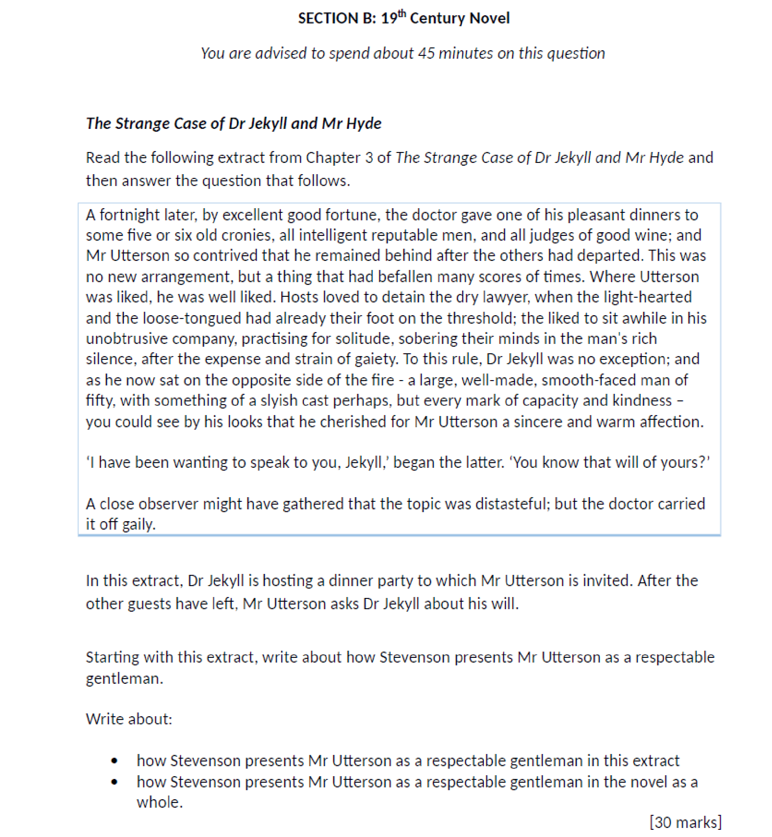

Read the following extract from Chapter 3 (Dr Jekyll is Quite at Ease) of The Strange Case of Dr Jekyll and Mr Hyde and then answer the question that follows.
In this extract, Mr Utterson asks Dr Jekyll about his will

A close observer might have gathered that the topic was distasteful; but the doctor carried it off gaily. “My poor Utterson,” said he, “you are unfortunate in such a client. I never saw a man so distressed as you were by my will; unless it were that hide-bound pedant, Lanyon, at what he called my scientific heresies. O, I know he’s a good fellow—you needn’t frown—an excellent fellow, and I always mean to see more of him; but a hide-bound pedant for all that; an ignorant, blatant pedant. I was never more disappointed in any man than Lanyon.”
“You know I never approved of it,” pursued Utterson, ruthlessly disregarding the fresh topic.
“My will? Yes, certainly, I know that,” said the doctor, a trifle sharply. “You have told me so.”
“Well, I tell you so again,” continued the lawyer. “I have been learning something of young Hyde.”
The large handsome face of Dr. Jekyll grew pale to the very lips, and there came a blackness about his eyes. “I do not care to hear more,” said he. “This is a matter I thought we had agreed to drop.”
“What I heard was abominable,” said Utterson.
“It can make no change. You do not understand my position,” returned the doctor, with a certain incoherency of manner. “I am painfully situated, Utterson; my position is a very strange—a very strange one. It is one of those affairs that cannot be mended by talking.”
“Jekyll,” said Utterson, “you know me: I am a man to be trusted. Make a clean breast of this in confidence; and I make no doubt I can get you out of it.”
“My good Utterson,” said the doctor, “this is very good of you, this is downright good of you, and I cannot find words to thank you in. I believe you fully; I would trust you before any man alive, ay, before myself, if I could make the choice; but indeed it isn’t what you fancy; it is not as bad as that; and just to put your good heart at rest, I will tell you one thing: the moment I choose, I can be rid of Mr. Hyde. I give you my hand upon that; and I thank you again and again; and I will just add one little word, Utterson, that I’m sure you’ll take in good part: this is a private matter, and I beg of you to let it sleep.”
Starting with this extract, to what extent do you believe that Dr Jekyll is a deceitful character?

Write about:
- how Stevenson presents Dr Jekyll as deceitful in this extract
- how Stevenson presents Hyde Dr Jekyll as deceitful in the novel as a whole

[30 marks]

Read the following extract from Chapter 4 (The Carew Murder Case) of The Strange Case of Dr Jekyll and Mr Hyde and then answer the question that follows.
In this extract, a maid recounts the murder of Sir Danvers Carew.


And as she so sat she became aware of an aged beautiful gentleman with white hair, drawing near along the lane; and advancing to meet him, another and very small gentleman, to whom at first she paid less attention. When they had come within speech (which was just under the maid's eyes) the older man bowed and accosted the other with a very pretty manner of politeness. It did not seem as if the subject of his address were of great importance; indeed, from his pointing, it some times appeared as if he were only inquiring his way; but the moon shone on his face as he spoke, and the girl was pleased to watch it, it seemed to breathe such an innocent and old-world kindness of disposition, yet with something high too, as of a wellfounded self-content. Presently her eye wandered to the other, and she was surprised to recognise in him a certain Mr. Hyde, who had once visited her master and for whom she had conceived a dislike. He had in his hand a heavy cane, with which he was trifling; but he answered never a word, and seemed to listen with an illcontained impatience. And then all of a sudden he broke out in a great flame of anger, stamping with his foot, brandishing the cane, and carrying on (as the maid described it) like a madman. The old gentleman took a step back, with the air of one very much surprised and a trifle hurt; and at that Mr. Hyde broke out of all bounds and clubbed him to the earth. And next moment, with ape-like fury, he was trampling his victim under foot and hailing down a storm of blows, under which the bones were audibly shattered and the body jumped upon the roadway. At the horror of these sights and sounds, the maid fainted.
Starting with this extract, how does Stevenson present Hyde as a violent character?

Write about:
- how Stevenson describes the violent actions of Mr Hyde
- how Stevenson present Hyde as a violent character in the novel as a whole

[30 marks]

Read the following extract from Chapter 4 (The Carew Murder Case) of The Strange Case of Dr Jekyll and Mr Hyde and then answer the question that follows.

In this extract, Utterson and a police inspector are on their way to Mr Hyde’s residence.

It was by this time about nine in the morning, and the first fog of the season. A great chocolate-coloured pall lowered over heaven, but the wind was continually charging and routing these embattled vapours; so that as the cab crawled from street to street, Mr. Utterson beheld a marvellous number of degrees and hues of twilight; for here it would be dark like the back-end of evening; and there would be a glow of a rich, lurid brown, like the light of some strange conflagration; and here, for a moment, the fog would be quite broken up, and a haggard shaft of daylight would glance in between the swirling wreaths. The dismal quarter of Soho seen under these changing glimpses, with its muddy ways, and slatternly passengers, and its lamps, which had never been extinguished or had been kindled afresh to combat this mournful reinvasion of darkness, seemed, in the lawyer’s eyes, like a district of some city in a nightmare. The thoughts of his mind, besides, were of the gloomiest dye; and when he glanced at the companion of his drive, he was conscious of some touch of that terror of the law and the law’s officers, which may at times assail the most honest.
5
15
10
As the cab drew up before the address indicated, the fog lifted a little and showed him a dingy street, a gin palace, a low French eating house, a shop for the retail of penny numbers and two-penny salads, many ragged children huddled in the doorways, and many women of many different nationalities passing out, key in hand, to have a morning glass; and the next moment the fog settled down again upon that part, as brown as umber, and cut him off from his blackguardly surroundings. This was the home of Henry Jekyll’s favourite; of a man who was heir to a quarter of a million sterling.
25
20

Starting with this extract, how does Stevenson use setting to build tension and fear?

Write about:
- how Stevenson uses setting to build tension in this extract
- how Stevenson uses setting to build tension in the novel as a whole

[30 marks]

Read the following extract from Chapter 4 (The Carew Murder Case) of The Strange Case of Dr Jekyll and Mr Hyde and then answer the question that follows.
In this extract, a maid recounts the murder of Sir Danvers Carew.
And as she so sat she became aware of an aged beautiful gentleman with white hair, drawing near along the lane; and advancing to meet him, another and very small gentleman, to whom at first she paid less attention. When they had come within speech (which was just under the maid's eyes) the older man bowed and accosted the other with a very pretty manner of politeness. It did not seem as if the subject of his address were of great importance; indeed, from his pointing, it some times appeared as if he were only inquiring his way; but the moon shone on his face as he spoke, and the girl was pleased to watch it, it seemed to breathe such an innocent and old-world kindness of disposition, yet with something high too, as of a wellfounded self-content. Presently her eye wandered to the other, and she was surprised to recognise in him a certain Mr. Hyde, who had once visited her master and for whom she had conceived a dislike. He had in his hand a heavy cane, with which he was trifling; but he answered never a word, and seemed to listen with an illcontained impatience. And then all of a sudden he broke out in a great flame of anger, stamping with his foot, brandishing the cane, and carrying on (as the maid described it) like a madman. The old gentleman took a step back, with the air of one very much surprised and a trifle hurt; and at that Mr. Hyde broke out of all bounds and clubbed him to the earth. And next moment, with ape-like fury, he was trampling his victim under foot and hailing down a storm of blows, under which the bones were audibly shattered and the body jumped upon the roadway. At the horror of these sights and sounds, the maid fainted.
Starting with this extract, how does Stevenson present Hyde as a violent character?
Write about:
- how Stevenson describes the violent actions of Mr Hyde
- how Stevenson present Hyde as a violent character in the novel as a whole

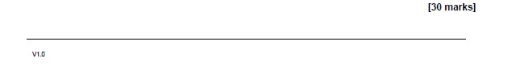

Read the following extract from Chapter 4 (The Carew Murder Case) of The Strange Case of Dr Jekyll and Mr Hyde and then answer the question that follows.
In this extract, Utterson and the policeman are on the way to Mr Hyde’s apartment.

It was by this time about nine in the morning, and the first fog of the season. A great chocolate-coloured pall lowered over heaven, but the wind was continually charging and routing these embattled vapours; so that as the cab crawled from street to street, Mr. Utterson beheld a marvellous number of degrees and hues of twilight; for here it would be dark like the back-end of evening; and there would be a glow of a rich, lurid brown, like the light of some strange conflagration; and here, for a moment, the fog would be quite broken up, and a haggard shaft of daylight would glance in between the swirling wreaths. The dismal quarter of Soho seen under these changing glimpses, with its muddy ways, and slatternly passengers, and its lamps, which had never been extinguished or had been kindled afresh to combat this mournful reinvasion of darkness, seemed, in the lawyer’s eyes, like a district of some city in a nightmare. The thoughts of his mind, besides, were of the gloomiest dye; and when he glanced at the companion of his drive, he was conscious of some touch of that terror of the law and the law’s officers, which may at times assail the most honest.
As the cab drew up before the address indicated, the fog lifted a little and showed him a dingy street, a gin palace, a low French eating house, a shop for the retail of penny numbers and two penny salads, many ragged children huddled in the doorways, and many women of many different nationalities passing out, key in hand, to have a morning glass; and the next moment the fog settled down again upon that part, as brown as umber, and cut him off from his blackguardly surroundings. This was the home of Henry Jekyll’s favourite; of a man who was heir to a quarter of a million sterling.

Starting with this extract, how does Stevenson use setting to build tension and foreshadow key events.
Write about:
- how Stevenson builds tension and foreshadow key events
- how Stevenson builds tension and foreshadow key events in the novel as a whole

Read the following extract from Chapter 5 (Incident of the Letter) of The Strange Case of Dr Jekyll and Mr Hyde and then answer the question that follows.
In this extract, Dr Jekyll informs Mr Utterson that he will never speak to Mr Hyde again.

"Utterson, I swear to God," cried the doctor, "I swear to God I will never set eyes on him again. I bind my honour to you that I am done
with him in this world. It is all at an end. And indeed he does not want
my help; you do not know him as I do; he is safe, he is quite safe; mark my words, he will never more be heard of."
The lawyer listened gloomily; he did not like his friend's feverish manner. "You seem pretty sure of him," said he; "and for your sake, I hope you may be right. If it came to a trial, your

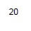

name might appear."
"I am quite sure of him," replied Jekyll; "I have grounds for certainty
that I cannot share with any one. But there is one thing on which you may advise me. I have--I have received a letter; and I am at a loss
whether I should show it to the police. I should like to leave it in your
hands, Utterson; you would judge wisely, I am sure; I have so great a trust in you."
"You fear, I suppose, that it might lead to his detection?" asked the lawyer.
"No," said the other. "I cannot say that I care what becomes of Hyde; I am quite done with him. I was thinking of my own character, which this hateful business has rather exposed."
Utterson ruminated awhile; he was surprised at his friend's selfishness, and yet relieved by it. "Well," said he, at last, let me see the letter."
The letter was written in an odd, upright hand and signed "Edward Hyde": and it signified, briefly enough, that the writer's benefactor, Dr.
Jekyll, whom he had long so unworthily repaid for a thousand
generosities, need labour under no alarm for his safety, as he had means
of escape on which he placed a sure dependence. The lawyer liked this
letter well enough; it put a better colour on the intimacy than he had looked for; and he blamed himself for some of his past suspicions.
Starting with this extract, how does Stevenson present relationships?
Write about:
- how Stevenson describes the relationship between Dr Jekyll and Mr Utterson
- how Stevenson present relationships in the novel as a whole

Read the following extract from Chapter 6 (Remarkable Incident of Dr Lanyon) of The Strange Case of Dr Jekyll and Mr Hyde and then answer the question that follows.
In this extract, Dr Lanyon informs Mr Utterson that he has had a shock and is soon to die.
There at least he was not denied admittance; but when he came in, he was shocked at the change which had taken place in the doctor's appearance. He had his death-warrant written legibly upon his face. The
rosy man had grown pale; his flesh had fallen away; he was visibly balder and older; and yet it was not so much these tokens of a swift physical
decay that arrested the lawyer's notice, as a look in the eye and quality of manner that seemed to testify to some deep-seated terror of the mind. It was unlikely that the doctor should fear death; and yet that was what
Utterson was tempted to suspect. "Yes," he thought; he is a doctor, he must know his own state and that his days are counted; and the knowledge is more than he can bear." And yet when Utterson remarked on his ill-looks, it was with an air of great firmness that Lanyon declared

himself a doomed man.
"I have had a shock," he said, "and I shall never recover. It is a
question of weeks. Well, life has been pleasant; I liked it; yes, sir, I used
to like it. I sometimes think if we knew all, we should be more glad to get away."
"Jekyll is ill, too," observed Utterson. "Have you seen him?"
But Lanyon's face changed, and he held up a trembling hand. "I wish to see or hear no more of Dr. Jekyll," he said in a loud, unsteady
voice. "I am quite done with that person; and I beg that you will spare me any allusion to one whom I regard as dead."
"Tut-tut," said Mr. Utterson; and then after a considerable pause, "Can't I do anything?" he inquired. "We are three very old friends, Lanyon; we shall not live to make others."
"Nothing can be done," returned Lanyon; "ask himself." "He will not see me," said the lawyer.
"I am not surprised at that," was the reply. "Some day, Utterson, after I am dead, you may perhaps come to learn the right and wrong of this.

Starting with this extract, how does Stevenson create sympathy for Dr Lanyon?
Write about:
- how Stevenson creates sympathy for Dr Lanyon
- how Stevenson creates sympathy in the novel as a whole
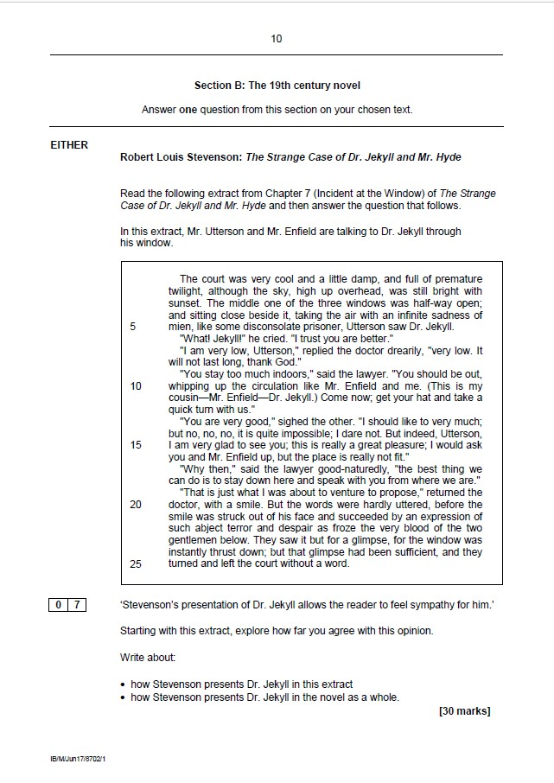

Read the following extract from Chapter 8 (The Last Night) of The Strange Case of Dr Jekyll and Mr Hyde and then answer the question that follows.
In this extract, Poole has sent for Mr Utterson and they are both on their way to Dr Jekyll’s house.
Mr. Utterson's only answer was to rise and get his hat and greatcoat; but he observed with wonder the greatness of the relief that appeared upon the butler's face, and perhaps with no less, that the wine was still untasted when he set it down to follow.
It was a wild, cold, seasonable night of March, with a pale moon, lying on her back as though the wind had tilted her, and flying wrack of the most diaphanous and lawny texture. The wind made talking difficult, and flecked the blood into the face. It seemed to have swept the streets

unusually bare of passengers, besides; for Mr. Utterson thought he had never seen that part of London so deserted. He could have wished it otherwise; never in his life had he been conscious of so sharp a wish to
see and touch his fellow-creatures; for struggle as he might, there was borne in upon his mind a crushing anticipation of calamity. The square,
when they got there, was full of wind and dust, and the thin trees in the garden were lashing themselves along the railing. Poole, who had kept all the way a pace or two ahead, now pulled up in the middle of the
pavement, and in spite of the biting weather, took off his hat and mopped his brow with a red pocket-handkerchief. But for all the hurry of his coming, these were not the dews of exertion that he wiped away, but the moisture of some strangling anguish; for his face was white and his voice, when he spoke, harsh and broken.

Starting with this extract, explore how Stevenson presents ideas about secrecy.
Write about:
- How Stevenson presents ideas about secrecy in this extract
- How Stevenson presents ideas about secrecy in the novel as a whole.
Starting with this extract, how does Stevenson use setting to create fear?
Write about:
- how Stevenson describes the setting in this extract
- how Stevenson uses setting to create fear in the novel as a whole

Read the following extract from Chapter 8 (The Last Night) of The Strange Case of Dr Jekyll and Mr Hyde and then answer the question that follows.
In this extract, Poole and Mr Utterson are outside Dr Jekyll’s cabinet and Poole has just informed Mr Hyde that Mr Utterson is here to see him. Dr Jekyll tells Poole that he wants no visitors.
"Sir," he said, looking Mr. Utterson in the eyes, "Was that my master's voice?" "It seems much changed," replied the lawyer, very pale, but giving look for look.
"Changed? Well, yes, I think so," said the butler. "Have I been twenty years in this man's house, to be deceived about his voice? No, sir; master's made away with; he was made away with eight days ago, when we heard him cry out upon

the name of God; and who's in there instead of him, and why it stays there, is a
thing that cries to Heaven, Mr. Utterson!"
"This is a very strange tale, Poole; this is rather a wild tale my man," said Mr.
Utterson, biting his finger. "Suppose it were as you suppose, supposing Dr. Jekyll to have been--well, murdered what could induce the murderer to stay? That won't
hold water; it doesn't commend itself to reason."
"Well, Mr. Utterson, you are a hard man to satisfy, but I'll do it yet," said
Poole. "All this last week (you must know) him, or it, whatever it is that lives in that cabinet, has been crying night and day for some sort of medicine and cannot get it to his mind. It was sometimes his way--the master's, that is—to write his orders on a sheet of paper and throw it on the stair. We've had nothing else this week back; nothing but papers, and a closed door, and the very meals left there to be smuggled in when nobody was looking. Well, sir, every day, ay, and twice and thrice in the same day, there have been orders and complaints, and I have been sent flying to all the wholesale chemists in town. Every time I brought the stuff back, there would be another paper telling me to return it, because it was not pure, and another order to a different firm. This drug is wanted bitter bad, sir, whatever for."


Starting with this extract, how does Stevenson present the effect of Jekyll’s scientific ambitions? Write about:
- how Stevenson presents the effects of Jekyll’s scientific ambitions in this extract
- how Stevenson presents the effects of Jekyll’s scientific ambitions in the novel as a whole

Read the following extract from Chapter 8 (The Last Night) of The Strange Case of Dr Jekyll and Mr Hyde and then answer the question that follows.
In this extract, Poole describes to Mr Utterson the character that he saw rummaging through the chemicals.

"It is well, then that we should be frank," said the other. "We both think more
than we have said; let us make a clean breast. This masked figure that you
saw, did you recognise it?"
"Well, sir, it went so quick, and the creature was so doubled up, that I could hardly swear to that," was the answer. "But if you mean, was it Mr. Hyde?--why,
yes, I think it was!" You see, it was much of the same bigness; and it had the
same quick, light way with it; and then who else could have got in by the
laboratory door? You have not forgot, sir, that at the time of the murder he had still the key with him? But that's not all. I don't know, Mr. Utterson, if you ever
met this Mr. Hyde?"
"Yes," said the lawyer, "I once spoke with him."
"Then you must know as well as the rest of us that there was something queer about that gentleman--something that gave a man a turn--I don't know
rightly how to say it, sir, beyond this: that you felt in your marrow kind of cold
and thin."
"I own I felt something of what you describe," said Mr. Utterson.
"Quite so, sir," returned Poole. "Well, when that masked thing like a monkey jumped from among the chemicals and whipped into the cabinet, it went down my spine like ice. O, I know it's not evidence, Mr. Utterson; I'm book-learned
enough for that; but a man has his feelings, and I give you my bible-word it was Mr.Hyde!"

"Ay, ay," said the lawyer. "My fears incline to the same point. Evil, I fear, founded--evil was sure to come--of that connection. Ay truly, I believe you; I
believe poor Harry is killed; and I believe his murderer (for what purpose, God alone can tell) is still lurking in his victim's room. Well, let our name be
vengeance. Call Bradshaw."

Starting with this extract, how does Stevenson present Mr Hyde?
Starting with this extract, explore how Stevenson presents reactions to Mr Hyde.
Write about:
- How Stevenson presents reactions to Mr Hyde in this extract
- How Stevenson presents reactions to Mr Hyde in the novel as a whole
Write about:
- how Stevenson presents Mr Hyde in this extract
- how Stevenson presents Mr Hyde in the novel as a whole

Read the following extract from Chapter 8 (The Last Night) of The Strange Case of Dr Jekyll and Mr Hyde and then answer the question that follows.
In this extract, Poole and Mr Utterson search for the body of Dr Jekyll.

The far greater proportion of the building was occupied by the theatre, which
filled almost the whole ground storey and was lighted from above, and by the
cabinet, which formed an upper story at one end and looked upon the court. A
corridor joined the theatre to the door on the by-street; and with this the cabinet
communicated separately by a second flight of stairs. There were besides a
few dark closets and a spacious cellar. All these they now thoroughly
examined. Each closet needed but a glance, for all were empty, and all, by the
dust that fell from their doors, had stood long unopened. The cellar, indeed, was filled with crazy lumber, mostly dating from the times of the surgeon who was Jekyll's predecessor; but even as they opened the door they were
advertised of the uselessness of further search, by the fall of a perfect mat of cobweb which had for years sealed up the entrance. No where was there any
trace of Henry Jekyll dead or alive.
Poole stamped on the flags of the corridor. "He must be buried here," he said, hearkening to the sound.
"Or he may have fled," said Utterson, and he turned to examine the door in the by-street. It was locked; and lying near by on the flags, they found the key,
already stained with rust.
"This does not look like use," observed the lawyer.
"Use!" echoed Poole. "Do you not see, sir, it is broken? much as if a man
had stamped on it."

"Ay," continued Utterson, "and the fractures, too, are rusty." The two men looked at each other with a scare. "This is beyond me, Poole," said the lawyer. "Let us go back to the cabinet."

‘Stevenson’s writing withholds key information from the reader, which creates mystery within the novel’
Explore how Stevenson uses settings to create tension.
Write about:
- How Stevenson uses setting to create tension in this extract
- How Stevenson uses setting to create tension in the novel as a whole.
Starting with this extract, explore how far you agree with this opinion.
Write about:
- how Stevenson creates mystery in this extract
- how Stevenson creates mystery in the novel as a whole

Read the following extract from Chapter 9 (Dr Lanyon’s Narrative) of The Strange Case of Dr Jekyll and Mr Hyde and then answer the question that follows.
In this extract, Dr Lanyon describes Mr Hyde.

These particulars struck me, I confess, disagreeably; and as I followed him into
the bright light of the consulting room, I kept my hand ready on my
weapon. Here, at last, I had a chance of clearly seeing him. I had never set
eyes on him before, so much was certain. He was small, as I have said; I was
struck besides with the shocking expression of his face, with his remarkable
combination of great muscular activity and great apparent debility of
constitution, and--last but not least--with the odd, subjective disturbance caused
by his neighbourhood. This bore some resemblance to incipient rigour, and was accompanied by a marked sinking of the pulse. At the time, I set it down to some idiosyncratic, personal distaste, and merely wondered at the acuteness of
the symptoms; but I have since had reason to believe the cause to lie much deeper in the nature of man, and to turn on some nobler hinge than the principle
of hatred.
This person (who had thus, from the first moment of his entrance, struck in me what I can only, describe as a disgustful curiosity) was dressed in a fashion that would have made an ordinary person laughable; his clothes, that is to say, although they were of rich and sober fabric, were enormously too large for him
in every measurement--the trousers hanging on his legs and rolled up to keep
them from the ground, the waist of the coat below his haunches, and the collar
sprawling wide upon his shoulders. Strange to relate, this ludicrous
accoutrement was far from moving me to laughter. Rather, as there was

something abnormal and misbegotten in the very essence of the creature that
now faced me--something seizing, surprising and revolting-- this fresh disparity seemed but to fit in with and to reinforce it; so that to my interest in the man's nature and character, there was added a curiosity as to his origin, his life, his fortune and status in the world.
These observations, though they have taken so great a space to be set down in, were yet the work of a few seconds. My visitor was, indeed, on fire with sombre excitement.

Starting with this extract, how does Stevenson present Mr Hyde?
Starting with this extract, explore how Stevenson presents Mr Hyde’s appearance.
Write about:
- How his appearance is described in this extract
- How Hyde’s appearance is described in the novel as a whole.
Write about:
- how Stevenson presents Mr Hyde in this extract
- how Stevenson presents Mr Hyde in the novel as a whole
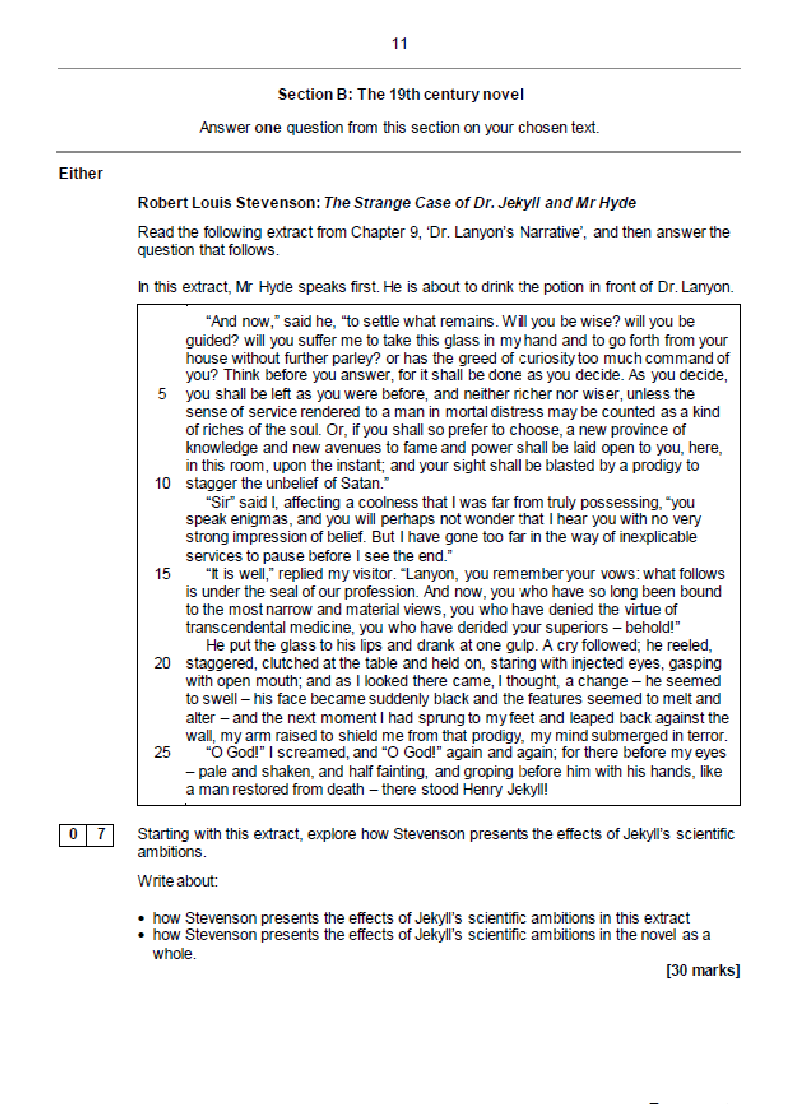
Starting with this extract, explore how Stevenson presents horrific events.
Write about:
- How an horrific event is presented in this extract
- How Stevenson presents horrific events in the novel as a whole.
- How an horrific event is presented in this extract
- How Stevenson presents horrific events in the novel as a whole.

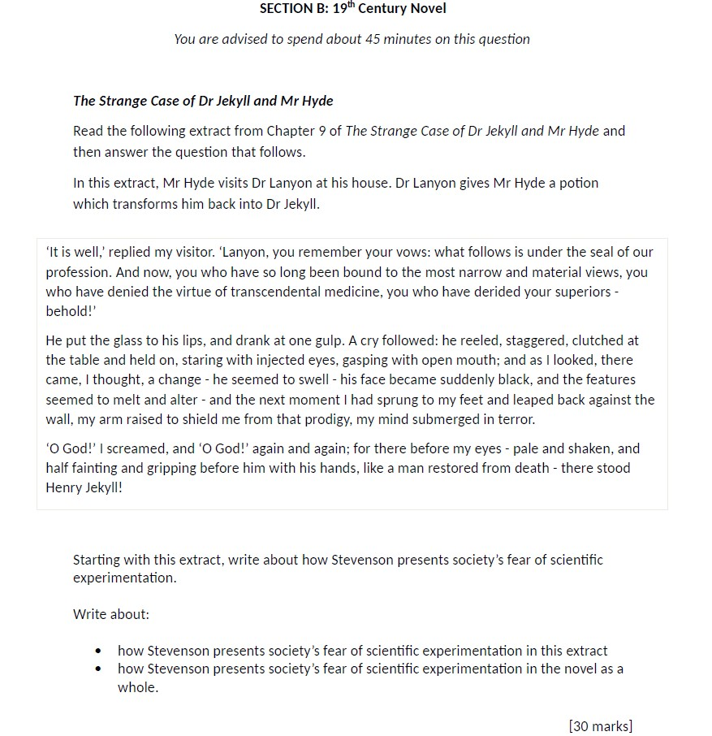

Read the following extract from Chapter 10 (Henry Jekyll’s Full Statement of the Case) of The Strange Case of Dr Jekyll and Mr Hyde and then answer the question that follows.
In this extract, Mr Utterson is reading the letter left to him by Dr Jekyll.

With every day, and from both sides of my intelligence, the moral and the intellectual, I thus drew steadily nearer to that truth, by whose partial discovery I
have been doomed to such a dreadful shipwreck: that man is not truly one, but
truly two. I say two, because the state of my own knowledge does not pass beyond that point. Others will follow, others will outstrip me on the same lines;
and I hazard the guess that man will be ultimately known for a mere polity of multifarious, incongruous and I independent denizens. I, for my part, from the nature of my life, advanced infallibly in one direction and in one direction only. It
was on the moral side, and in my own person, that I learned to recognise the thorough and primitive duality of man; I saw that, of the two natures that
contended in the field of my consciousness, even if I could rightly be said to be
either, it was only because I was radically both; and from an early date, even before the course of my scientific discoveries had begun to suggest the most
naked possibility of such a miracle, I had learned to dwell with pleasure, as a beloved daydream, on the thought of the separation of these elements. If each,
I told myself, could be housed in separate identities, life would be relieved of all that was unbearable; the unjust might go his way, delivered from the aspirations and remorse of his more upright twin; and the just could walk steadfastly and
securely on his upward path, doing the good things in which he found his
pleasure, and no longer exposed to disgrace and penitence by the hands of this
extraneous evil. It was the curse of mankind that these incongruous faggots

were thus bound together--that in the agonised womb of consciousness, these
polar twins should be continuously struggling. How, then were they dissociated?

Starting with this extract, how does Stevenson the theme of duality?
Write about:
- how Stevenson presents duality in this extract
- how Stevenson presents duality in the novel as a whole

Read the following extract from Chapter 10 (Henry Jekyll’s Full Statement of the Case) of The Strange Case of Dr Jekyll and Mr Hyde and then answer the question that follows.
In this extract, Mr Utterson is reading the letter left to him by Dr Jekyll.

Certain agents I found to have the power to shake and pluck back that fleshly
vestment, even as a wind might toss the curtains of a pavilion. For two good
reasons, I will not enter deeply into this scientific branch of my confession. First,
because I have been made to learn that the doom and burthen of our life is
bound for ever on man's shoulders, and when the attempt is made to cast it off,
it but returns upon us with more unfamiliar and more awful pressure. Second, because, as my narrative will make, alas! too evident, my discoveries were
incomplete. Enough then, that I not only recognised my natural body from the mere aura and effulgence of certain of the powers that made up my spirit, but managed to compound a drug by which these powers should be dethroned from
their supremacy, and a second form and countenance substituted, none the less natural to me because they were the expression, and bore the stamp of
lower elements in my soul.
I hesitated long before I put this theory to the test of practice. I knew well that
I risked death; for any drug that so potently controlled and shook the very fortress of identity, might, by the least scruple of an overdose or at the least
inopportunity in the moment of exhibition, utterly blot out that immaterial

tabernacle which I looked to it to change. But the temptation of a discovery so
singular and profound at last overcame the suggestions of alarm. I had long
since prepared my tincture; I purchased at once, from a firm of wholesale
chemists, a large quantity of a particular salt which I knew, from my
experiments, to be the last ingredient required; and late one accursed night, I
compounded the elements, watched them boil and smoke together in the glass,
and when the ebullition had subsided, with a strong glow of courage, drank off the potion.

Starting with this extract, explore how Stevenson presents the dangers of scientific experimentation.
Write about:
- How Stevenson presents the dangers of scientific experimentation in this extract
- How Stevenson presents the dangers of scientific experimentation in the novel as a whole.

Starting with this extract, how does Stevenson present Jekyll’s scientific ambition?
Write about:
- how Stevenson presents Jekyll’s scientific ambition in this extract
- how Stevenson presents Jekyll’s scientific ambition in the novel as a whole

Read the following extract from Chapter 10 (Henry Jekyll’s Full Statement of the Case) of The Strange Case of Dr Jekyll and Mr Hyde and then answer the question that follows.
In this extract, Mr Utterson is reading the letter left to him by Dr Jekyll.

The most racking pangs succeeded: a grinding in the bones, deadly nausea,
and a horror of the spirit that cannot be exceeded at the hour of birth or
death. Then these agonies began swiftly to subside, and I came to myself as if
out of a great sickness. There was something strange in my sensations, something indescribably new and, from its very novelty, incredibly sweet. I
felt younger, lighter, happier in body; within I was conscious of a heady
recklessness, a current of disordered sensual images running like a millrace in
my fancy, a solution of the bonds of obligation, an unknown but not an innocent freedom of the soul. I knew myself, at the first breath of this new life, to be more
wicked, tenfold more wicked, sold a slave to my original evil; and the thought, in
that moment, braced and delighted me like wine. I stretched out my hands, exulting in the freshness of these sensations; and in the act, I was suddenly
aware that I had lost in stature.
There was no mirror, at that date, in my room; that which stands beside me as I write, was brought there later on and for the very purpose of these
transformations. The night however, was far gone into the morning--the
morning, black as it was, was nearly ripe for the conception of the day--the

inmates of my house were locked in the most rigorous hours of slumber; and I
determined, flushed as I was with hope and triumph, to venture in my new
shape as far as to my bedroom. I crossed the yard, wherein the constellations
looked down upon me, I could have thought, with wonder, the first creature of that sort that their unsleeping vigilance had yet disclosed to them; I stole
through the corridors, a stranger in my own house; and coming to my room, I
saw for the first time the appearance of Edward Hyde.

Starting with this extract, how does Stevenson present the changes within Dr Jekyll?
Write about:
- how Stevenson presents the changes within Dr Jekyll in this extract
- how Stevenson presents the changes within Dr Jekyll in the novel as a whole

Read the following extract from Chapter 10 (Henry Jekyll’s Full Statement of the Case) of The Strange Case of Dr Jekyll and Mr Hyde and then answer the question that follows.
In this extract, Mr Utterson is reading the letter left to him by Dr Jekyll.

I must here speak by theory alone, saying not that which I know, but that which I suppose to be most probable. The evil side of my nature, to which I had now
transferred the stamping efficacy, was less robust and less developed than the
good which I had just deposed. Again, in the course of my life, which had been,
after all, nine tenths a life of effort, virtue and control, it had been much less
exercised and much less exhausted. And hence, as I think, it came about that Edward Hyde was so much smaller, slighter and younger than Henry Jekyll. Even as good shone upon the countenance of the one, evil was written broadly and plainly on the face of the other. Evil besides (which I must still believe to be
the lethal side of man) had left on that body an imprint of deformity and decay.
And yet when I looked upon that ugly idol in the glass, I was conscious of no repugnance, rather of a leap of welcome. This, too, was myself. It seemed
natural and human. In my eyes it bore a livelier image of the spirit, it seemed more express and single, than the imperfect and divided countenance I had
been hitherto accustomed to call mine. And in so far I was doubtless right. I have observed that when I wore the semblance of Edward Hyde, none could come near to me at first without a visible misgiving of the flesh. This, as I take
it, was because all human beings, as we meet them, are commingled out of
good and evil: and Edward Hyde, alone in the ranks of mankind, was pure evil.
I lingered but a moment at the mirror: the second and conclusive experiment
had yet to be attempted; it yet remained to be seen if I had lost my identity

beyond redemption and must flee before daylight from a house that was no
longer mine; and hurrying back to my cabinet, I once more prepared and drank
the cup, once more suffered the pangs of dissolution, and came to myself once more with the character, the stature and the face of Henry Jekyll.

Starting with this extract, how does Stevenson present good versus evil?
Write about:
- how Stevenson presents good versus evil in this extract
- how Stevenson presents good versus evil in the novel as a whole

Read the following extract from Chapter 10 (Henry Jekyll’s Full Statement of the Case) of The Strange Case of Dr Jekyll and Mr Hyde and then answer the question that follows.
In this extract, Mr Utterson is reading the letter left to him by Dr Jekyll.

That night I had come to the fatal cross-roads. Had I approached my discovery
in a more noble spirit, had I risked the experiment while under the empire of
generous or pious aspirations, all must have been otherwise, and from these
agonies of death and birth, I had come forth an angel instead of a fiend. The drug had no discriminating action; it was neither diabolical nor divine; it but
shook the doors of the prison-house of my disposition; and like the captives of
Philippi, that which stood within ran forth. At that time my virtue slumbered; my evil, kept awake by ambition, was alert and swift to seize the occasion; and the thing that was projected was Edward Hyde. Hence, although I had now two characters as well as two appearances, one was wholly evil, and the other was
still the old Henry Jekyll, that incongruous compound of whose reformation and improvement I had already learned to despair. The movement was thus wholly
toward the worse.
Even at that time, I had not conquered my aversions to the dryness of a life of study. I would still be merrily disposed at times; and as my pleasures were (to say the least) undignified, and I was not only well known and highly considered, but growing towards the elderly man, this incoherency of my life was daily
growing more unwelcome. It was on this side that my new power tempted me
until I fell in slavery. I had but to drink the cup, to doff at once the body of the
noted professor, and to assume, like a thick cloak, that of Edward Hyde. I
smiled at the notion; it seemed to me at the time to be humorous; and I made

my preparations with the most studious care. I took and furnished that house in
Soho, to which Hyde was tracked by the police; and engaged as a housekeeper a creature whom I knew well to be silent and unscrupulous. On the other side, I
announced to my servants that a Mr. Hyde (whom I described) was to have full liberty and power about my house in the square; and to parry mishaps, I even called and made myself a familiar object, in my second character.

Starting with this extract, how does Stevenson present Dr Jekyll’s ambition?
Starting with this extract, explore how Stevenson presents the dual nature of man.
Write about:
- How duality of nature is presented in this extract
- How Stevenson presents duality in the novel as a whole.
[30 marks]
Write about:
- how Stevenson presents Dr Jekyll’s ambition in this extract
- how Stevenson presents Dr Jekyll’s ambition in the novel as a whole

Read the following extract from Chapter 10 (Henry Jekyll’s Full Statement of the Case) of The Strange Case of Dr Jekyll and Mr Hyde and then answer the question that follows.
In this extract, Mr Utterson is reading the letter left to him by Dr Jekyll.

Men have before hired bravos to transact their crimes, while their own person
and reputation sat under shelter. I was the first that ever did so for his
pleasures. I was the first that could plod in the public eye with a load of genial
respectability, and in a moment, like a schoolboy, strip off these lendings and spring headlong into the sea of liberty. But for me, in my impenetrable mantle,
the safely was complete. Think of it—I did not even exist! Let me but escape into my laboratory door, give me but a second or two to mix and swallow the
draught that I had always standing ready; and whatever he had done, Edward
Hyde would pass away like the stain of breath upon a mirror; and there in his stead, quietly at home, trimming the midnight lamp in his study, a man who
could afford to laugh at suspicion, would be Henry Jekyll.
The pleasures which I made haste to seek in my disguise were, as I have said, undignified; I would scarce use a harder term. But in the hands of Edward
Hyde, they soon began to turn toward the monstrous. When I would come back from these excursions, I was often plunged into a kind of wonder at my vicarious depravity. This familiar that I called out of my own soul, and sent forth alone to do his good pleasure, was a being inherently malign and villainous; his every
act and thought centered on self; drinking pleasure with bestial avidity from any
degree of torture to another; relentless like a man of stone. Henry Jekyll stood
at times aghast before the acts of Edward Hyde; but the situation was apart
from ordinary laws, and insidiously relaxed the grasp of conscience. It was

Hyde, after all, and Hyde alone, that was guilty. Jekyll was no worse; he woke again to his good qualities seemingly unimpaired; he would even make haste,
where it was possible, to undo the evil done by Hyde. And thus his conscience slumbered.

Starting with this extract, how does Stevenson present the importance of being respectable in the Victorian era?
Write about:
- how Stevenson presents the importance of respectability in this extract
- how Stevenson presents the importance of respectability in the novel as a whole

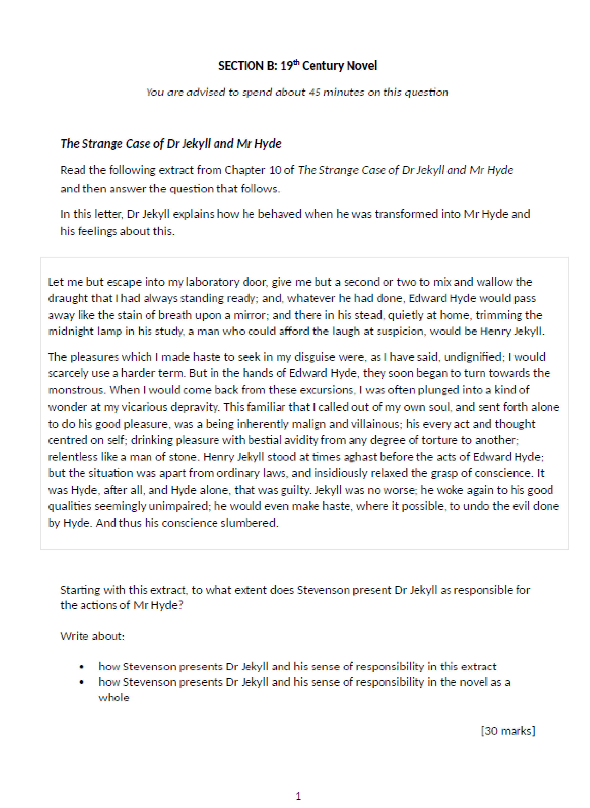

Read the following extract from Chapter 10 (Henry Jekyll’s Full Statement of the Case) of The Strange Case of Dr Jekyll and Mr Hyde and then answer the question that follows.
In this extract, Mr Utterson is reading the letter left to him by Dr Jekyll.

I do not suppose that, when a drunkard reasons with himself upon his vice, he is
once out of five hundred times affected by the dangers that he runs through his
brutish, physical insensibility; neither had I, long as I had considered my
position, made enough allowance for the complete moral insensibility and
insensate readiness to evil, which were the leading characters of Edward
Hyde. Yet it was by these that I was punished. My devil had been long caged, he came out roaring. I was conscious, even when I took the draught, of a more
unbridled, a more furious propensity to ill. It must have been this, I suppose, that stirred in my soul that tempest of impatience with which I listened to the civilities of my unhappy victim; I declare, at least, before God, no man morally sane could
have been guilty of that crime upon so pitiful a provocation; and that I struck in no more reasonable spirit than that in which a sick child may break a plaything. But I
had voluntarily stripped myself of all those balancing instincts by which even the worst of us continues to walk with some degree of steadiness among
temptations; and in my case, to be tempted, however slightly, was to fall.
Instantly the spirit of hell awoke in me and raged. With a trans sort of glee, I mauled the unresisting body, tasting delight from every blow; and it was not till
weariness had begun to succeed, that I was suddenly, in the top fit of my
delirium, struck through the heart by a cold thrill of terror. A mist dispersed; I saw
my life to be forfeit; and fled from the scene of these excesses, at once glorying and trembling, my lust of evil gratified and stimulated, my love of life screwed to

the topmost peg. I ran to the house in Soho, and (to make assurance doubly
sure) destroyed my papers; thence I set out through the lamplit streets, in the
same divided ecstasy of mind, gloating on my crime, light-headedly devising others in the future, and yet still hastening and still harkening in my wake for the steps of the avenger. Hyde had a song upon his lips as he compounded the draught, and as he drank it, pledged the dead man. The pangs of transformation had not done tearing him, before Henry Jekyll, with streaming tears of gratitude and remorse, had fallen upon his knees and lifted his clasped hands to God.

Starting with this extract, how does Stevenson present the power of Mr Hyde?
Write about:
- how Stevenson presents the power of Mr Hyde in this extract
- how Stevenson presents the power of Mr Hyde in the novel as a whole

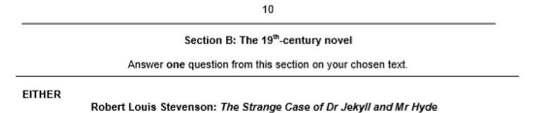

Read the following extract from Chapter 10 (Henry Jekyll’s Full Statement of the Case) of The Strange Case of Dr Jekyll and Mr Hyde and then answer the question that follows.
In this extract, Mr Utterson is reading the letter left to him by Dr Jekyll.
I do not suppose that, when a drunkard reasons with himself upon his vice, he is
once out of five hundred times affected by the dangers that he runs through his
brutish, physical insensibility; neither had I, long as I had considered my
position, made enough allowance for the complete moral insensibility and
insensate readiness to evil, which were the leading characters of Edward
Hyde. Yet it was by these that I was punished. My devil had been long caged, he came out roaring. I was conscious, even when I took the draught, of a more
unbridled, a more furious propensity to ill. It must have been this, I suppose, that stirred in my soul that tempest of impatience with which I listened to the civilities of my unhappy victim; I declare, at least, before God, no man morally sane could
have been guilty of that crime upon so pitiful a provocation; and that I struck in no more reasonable spirit than that in which a sick child may break a plaything. But I
had voluntarily stripped myself of all those balancing instincts by which even the worst of us continues to walk with some degree of steadiness among
temptations; and in my case, to be tempted, however slightly, was to fall.
Instantly the spirit of hell awoke in me and raged. With a trans sort of glee, I mauled the unresisting body, tasting delight from every blow; and it was not till
weariness had begun to succeed, that I was suddenly, in the top fit of my
delirium, struck through the heart by a cold thrill of terror. A mist dispersed; I saw
my life to be forfeit; and fled from the scene of these excesses, at once glorying and trembling, my lust of evil gratified and stimulated, my love of life screwed to

the topmost peg. I ran to the house in Soho, and (to make assurance doubly
sure) destroyed my papers; thence I set out through the lamplit streets, in the
same divided ecstasy of mind, gloating on my crime, light-headedly devising others in the future, and yet still hastening and still harkening in my wake for the steps of the avenger. Hyde had a song upon his lips as he compounded the draught, and as he drank it, pledged the dead man. The pangs of transformation had not done tearing him, before Henry Jekyll, with streaming tears of gratitude and remorse, had fallen upon his knees and lifted his clasped hands to God.

‘Stevenson’s presentation of Mr Hyde’s power allows the reader to feel sympathy for Dr Jekyll’
Starting with this extract, explore how Stevenson presents the conflict between science and religion.
Write about:
- How Stevenson presents the conflict between science and religion in this extract
- How Stevenson presents the conflict between science and religion in the novel as a whole.

[30 marks]

Starting with this extract, explore how far you agree with this opinion.

Write about:
- how Stevenson creates sympathy for Dr Jekyll in this extract
- how Stevenson creates sympathy for Dr Jekyll in the novel as a whole

Read the following extract from Chapter 10 (Henry Jekyll’s Full Statement of the Case) of The Strange Case of Dr Jekyll and Mr Hyde and then answer the question that follows.
In this extract, Mr Utterson is reading the letter left to him by Dr Jekyll.

Thereupon, I arranged my clothes as best I could, and summoning a passing hansom, drove to an hotel in Portland Street, the name of which I chanced to remember. At my appearance (which was indeed comical enough, however
tragic a fate these garments covered) the driver could not conceal his mirth. I
gnashed my teeth upon him with a gust of devilish fury; and the smile withered
from his face--happily for him--yet more happily for myself, for in another instant
I had certainly dragged him from his perch. At the inn, as I entered, I looked about me with so black a countenance as made the attendants tremble; not a
look did they exchange in my presence; but obsequiously took my orders, led me to a private room, and brought me wherewithal to write. Hyde in danger of his life was a creature new to me; shaken with inordinate anger, strung to the
pitch of murder, lusting to inflict pain. Yet the creature was astute; mastered his
fury with a great effort of the will; composed his two important letters, one to Lanyon and one to Poole; and that he might receive actual evidence of their being posted, sent them out with directions that they should be registered.
vvThenceforward, he sat all day over the fire in the private room, gnawing his
nails; there he dined, sitting alone with his fears, the waiter visibly quailing before his eye; and thence, when the night was fully come, he set forth in the corner of a closed cab, and was driven to and fro about the streets of the
city. He, I say--I cannot say, I. That child of Hell had nothing human; nothing
lived in him but fear and hatred. And when at last, thinking the driver had begun

to grow suspicious, he discharged the cab and ventured on foot, attired in his
misfitting clothes, an object marked out for observation, into the midst of the nocturnal passengers, these two base passions raged within him like a tempest.
He walked fast, hunted by his fears, chattering to himself, skulking through the
less frequented thoroughfares, counting the minutes that still divided him from
midnight. Once a woman spoke to him, offering, I think, a box of lights. He smote her in the face, and she fled.
Starting with this extract, how does Stevenson present Mr Hyde?
Starting with this extract, explore how Stevenson presents ideas about duality.
Write about:
- How Stevenson presents ideas about duality in this extract
- How Stevenson presents ideas about duality in the novel as a whole.

Write about:
- how Stevenson presents Mr Hyde in this extract
- how Stevenson presents Mr Hyde in the novel as a whole

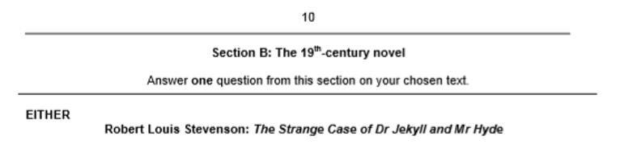

Read the following extract from Chapter 10 (Henry Jekyll’s Full Statement of the Case) of The Strange Case of Dr Jekyll and Mr Hyde and then answer the question that follows.
In this extract, Mr Utterson is reading the letter left to him by Dr Jekyll.

The powers of Hyde seemed to have grown with the sickliness of Jekyll. And certainly the hate that now divided them was equal on each side. With Jekyll, it
was a thing of vital instinct. He had now seen the full deformity of that creature
that shared with him some of the phenomena of consciousness, and was co heir with him to death: and beyond these links of community, which in
themselves made the most poignant part of his distress, he thought of Hyde, for
all his energy of life, as of something not only hellish but inorganic. This was the shocking thing; that the slime of the pit seemed to utter cries and voices;
that the amorphous dust gesticulated and sinned; that what was dead, and had
no shape, should usurp the offices of life. And this again, that that insurgent
horror was knit to him closer than a wife, closer than an eye; lay caged in his
flesh, where he heard it mutter and felt it struggle to be born; and at every hour of weakness, and in the confidence of slumber, prevailed against him, and deposed him out of life. The hatred of Hyde for Jekyll was of a different
order. His terror of the gallows drove him continually to commit temporary suicide, and return to his subordinate station of a part instead of a person; but

he loathed the necessity, he loathed the despondency into which Jekyll was
now fallen, and he resented the dislike with which he was himself regarded.
Hence the ape-like tricks that he would play me, scrawling in my own hand blasphemies on the pages of my books, burning the letters and destroying the portrait of my father; and indeed, had it not been for his fear of death, he would
long ago have ruined himself in order to involve me in the ruin. But his love of me is wonderful; I go further: I, who sicken and freeze at the mere
thought of him, when I recall the abjection and passion of this attachment, and
when I know how he fears my power to cut him off by suicide, I find it in my heart to pity him.

Starting with this extract, how does Stevenson the relationship between Mr Hyde and Dr Jekyll?
Write about:
- how Stevenson presents the relationship in this extract
- how Stevenson presents the relationship between Mr Hyde and Dr Jekyll in the novel as a whole

Read the following extract from Chapter 10 (Henry Jekyll’s Full Statement of the Case) of The Strange Case of Dr Jekyll and Mr Hyde and then answer the question that follows.
In this extract, Mr Utterson is reading the letter left to him by Dr Jekyll.
About a week has passed, and I am now finishing this statement under the influence of the last of the old powders. This, then, is the last time, short of a
miracle, that Henry Jekyll can think his own thoughts or see his own face (now
how sadly altered!) in the glass. Nor must I delay too long to bring my writing to
an end; for if my narrative has hitherto escaped destruction, it has been by a

combination of great prudence and great good luck. Should the throes of
change take me in the act of writing it, Hyde will tear it in pieces; but if some
time shall have elapsed after I have laid it by, his wonderful selfishness and
circumscription to the moment will probably save it once again from the action of his ape-like spite. And indeed the doom that is closing on us both has already
changed and crushed him. Half an hour from now, when I shall again and
forever reindue that hated personality, I know how I shall sit shuddering and
weeping in my chair, or continue, with the most strained and fear-struck ecstasy

of listening, to pace up and down this room (my last earthly refuge) and give ear
to every sound of menace. Will Hyde die upon the scaffold? or will he find courage to release himself at the last moment? God knows; I am careless; this
is my true hour of death, and what is to follow concerns another than myself.
Here then, as I lay down the pen and proceed to seal up my confession, I bring the life of that unhappy Henry Jekyll to an end.

‘This close of the novel is effective’
Starting with this extract, explore how far you agree with this statement.

Write about:
- Your own impressions of the novel’s conclusion
- Your own impressions of Stevenson’s methods used throughout the novel as a whole.

