Act 1 Scene 1 – Dramatic and interesting

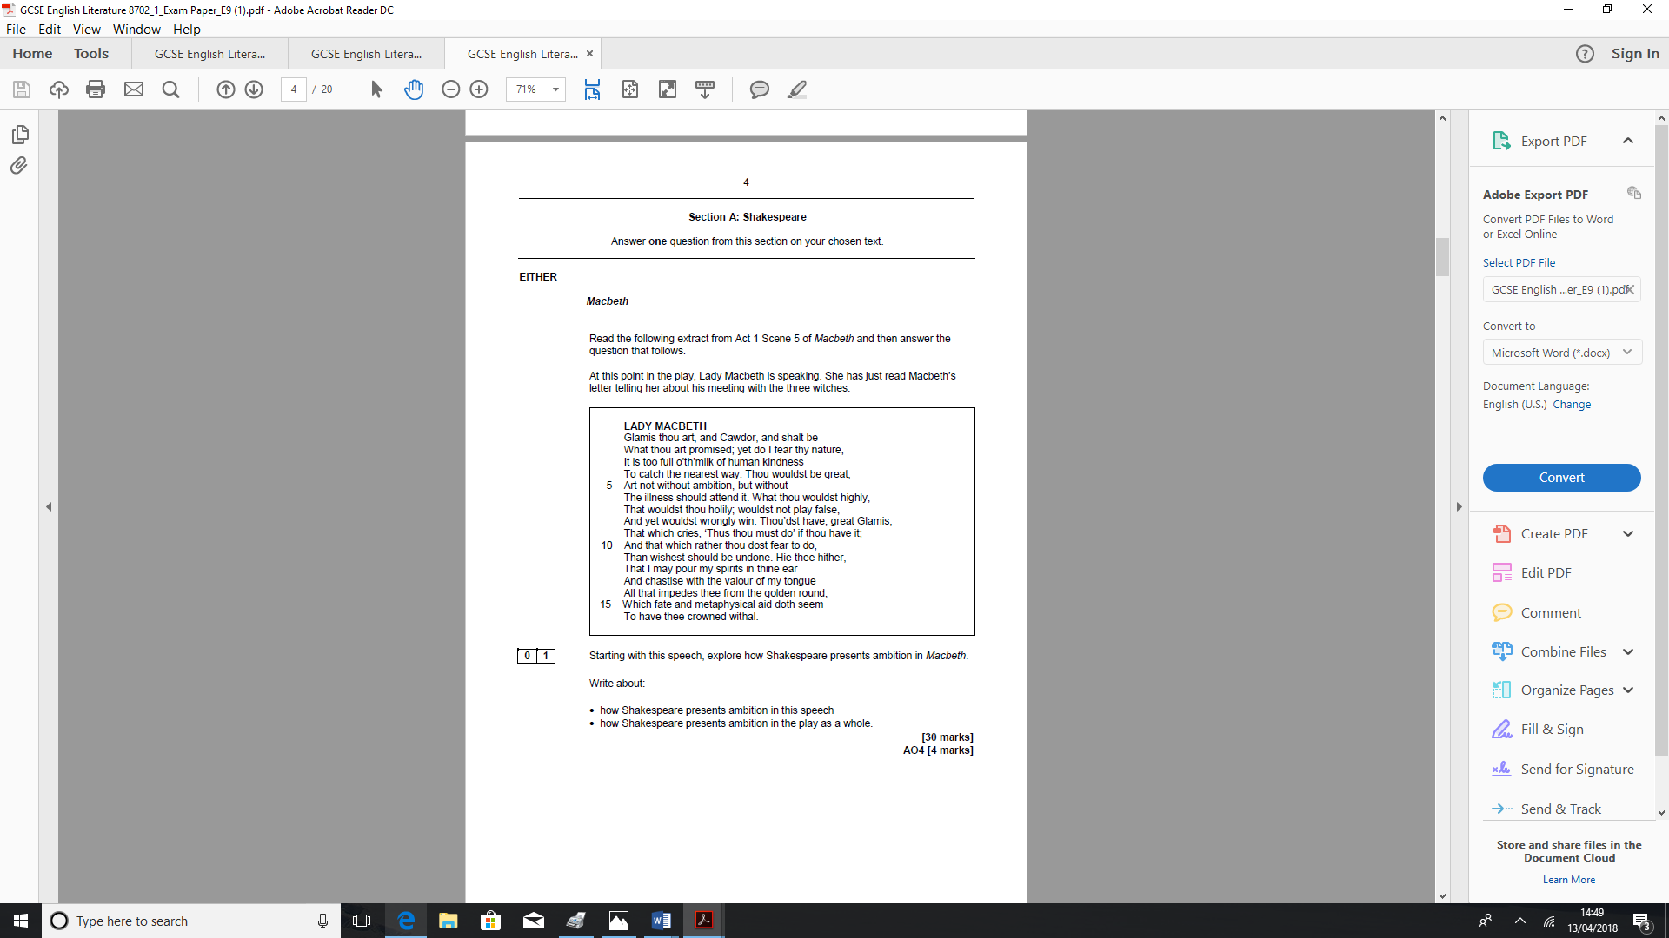
Macbeth
Read the following extract from Act 1 Scene 1 of Macbeth and then answer the question that follows.
At this point in the play, three witches vow to meet Macbeth after the battle. They respond to the calls of their familiar spirits. They leave chanting ominous words.

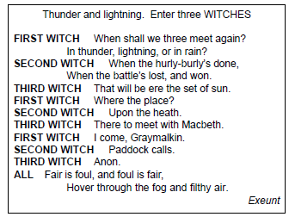

Starting with this speech, explore how Shakespeare makes the play dramatic and interesting
Write about:
- How Shakespeare makes this scene dramatic and interesting
- How Shakespeare creates drama and interest in the play as a whole.
Act 1 Scene 2 – Dramatic and interesting

Macbeth
Read the following extract from Act 1 Scene 2 of Macbeth and then answer the question that follows.
At this point in the play, the wounded captain reports that although the rebel Macdonald had strong forces, Macbeth personally killed him.
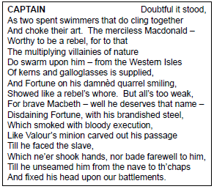

Starting with this speech, explore how Shakespeare makes the play dramatic and interesting
Write about:
- How Shakespeare makes this scene dramatic and interesting
- How Shakespeare creates drama and interest in the play as a whole.

Act 1 Scene 2 – Macbeth as a hero
Macbeth
Read the following extract from Act 1 Scene 2 of Macbeth and then answer the question that follows.
At this point in the play, the wounded Captain reports to King Duncan that when Macbeth and Banquo were faced with an assault by fresh Norwegian troops, they fought on undaunted.

CAPTAIN
Mark, king of Scotland, mark:
No sooner justice had with valour arm'd
Compell'd these skipping kerns to trust their heels,
But the Norweyan lord surveying vantage,
With furbish'd arms and new supplies of men
Began a fresh assault.
DUNCAN
Dismay'd not this
Our captains, Macbeth and Banquo?
CAPTAIN
Yes;
As sparrows eagles, or the hare the lion.
If I say sooth, I must report they were
As cannons overcharged with double cracks, so they
Doubly redoubled strokes upon the foe:
Except they meant to bathe in reeking wounds,
Or memorise another Golgotha,
I cannot tell.

Starting with this speech, explore how Shakespeare presents Macbeth as a hero
Write about:
- How Shakespeare presents Macbeth as a hero in this speech
- How Shakespeare presents Macbeth as a hero in the play as a whole.

Act 1 Scene 3 – the Witches
Macbeth
Read the following extract from Act 1 Scene 2 of Macbeth and then answer the question that follows.
At this point in the play, the witches await Macbeth. They plot to torment a sea captain whose wife has insulted them. A drum signals the approach of Macbeth.
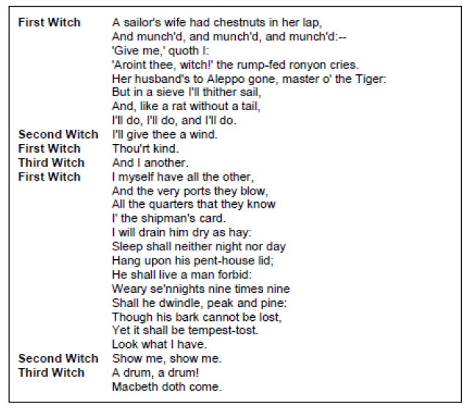
Starting with this speech, explore how Shakespeare presents the witches
Write about:
- How Shakespeare presents the witches in this speech
- How Shakespeare presents the witches in the play as a whole.

Act 1 Scene 3 – The Witches
Macbeth
Read the following extract from Act 1 Scene 3 of Macbeth and then answer the question that follows.
At this point in the play, Macbeth and Banquo have met the Witches. They amaze Macbeth with their predictions that he will be Thane of Cawdor and King of Scotland. Banquo demands to know his own future.

MACBETH
So foul and fair a day I have not seen.
BANQUO
How far is't call'd to Forres? What are these
So wither'd and so wild in their attire,
That look not like the inhabitants o' the earth,
And yet are on't? Live you? or are you aught
That man may question? You seem to understand me,
By each at once her chappy finger laying
Upon her skinny lips: you should be women,
And yet your beards forbid me to interpret
That you are so.
MACBETH
Speak, if you can: what are you?
First Witch
All hail, Macbeth! hail to thee, thane of Glamis!
Second Witch
All hail, Macbeth, hail to thee, thane of Cawdor!
Third Witch
All hail, Macbeth, thou shalt be king hereafter!
BANQUO
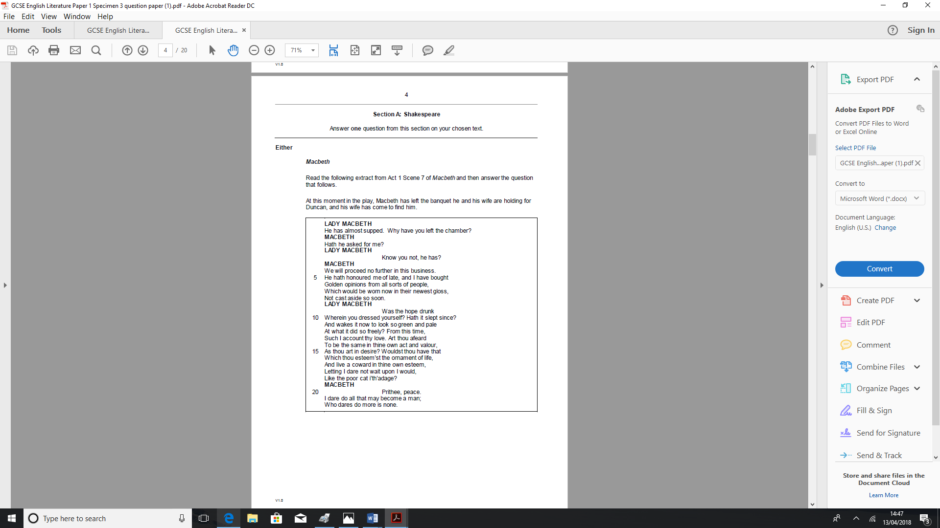
Good sir, why do you start; and seem to fear
Things that do sound so fair? I' the name of truth,
Are ye fantastical, or that indeed
Which outwardly ye show? My noble partner
You greet with present grace and great prediction
Of noble having and of royal hope,
That he seems rapt withal: to me you speak not.
Starting with this speech, explore how Shakespeare presents the Witches
Write about:
- How Shakespeare presents the Witches in this extract
- How Shakespeare presents the Witches in the play as a whole.
Act 1 Scene 3 – Macbeth’s or Banquo’s thoughts and feelings

Macbeth
Read the following extract from Act 1 Scene 3 of Macbeth and then answer the question that follows.
At this point in the play, Banquo warns that the Witches’ predictions might lead to evil.

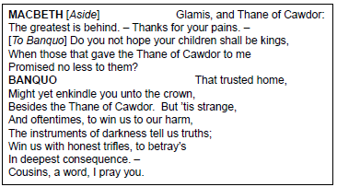

Starting with this speech, explore how Shakespeare presents the relationship of Macbeth and Banquo
Write about:
- How Shakespeare presents the relationship of Banquo and Macbeth in this extract
- How Shakespeare presents the relationship of Banquo and Macbeth in the play as a whole.

Act 1 Scene 3 – Macbeth’s thoughts and feelings
Macbeth
Read the following extract from Act 1 Scene 3 of Macbeth and then answer the question that follows.
At this point in the play, Macbeth weighs the moral implications of the Witches’ prediction. He is horrified at the thought of killing Duncan but resolves to accept whatever has to be.

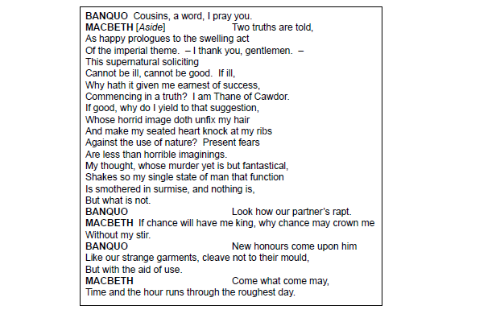

Starting with this speech, explore how Shakespeare presents Macbeth’s thoughts and feelings
Write about:
- How Shakespeare presents Macbeth’s thoughts and feelings in this extract
- How Shakespeare presents Macbeth’s thoughts and feelings in the play as a whole.

Act 1 Scene 4 – Appearance and reality
Macbeth
Read the following extract from Act 1 Scene 4 of Macbeth and then answer the question that follows.
At this point in the play, Malcolm reports that the Thane of Cawdor died a repentant and dignified death. Duncan reflects that it is impossible to judge anyone by their outward appearance. He warmly welcomes Macbeth.

MALCOLM
he died
As one that had been studied in his death
To throw away the dearest thing he owed,
As 'twere a careless trifle.
DUNCAN
There's no art
To find the mind's construction in the face:
He was a gentleman on whom I built
An absolute trust.
Enter MACBETH, BANQUO, ROSS, and ANGUS

O worthiest cousin!
The sin of my ingratitude even now
Was heavy on me: thou art so far before
That swiftest wing of recompense is slow
To overtake thee. Would thou hadst less deserved,
That the proportion both of thanks and payment
Might have been mine! only I have left to say,
More is thy due than more than all can pay.
MACBETH
The service and the loyalty I owe,
In doing it, pays itself. Your highness' part
Is to receive our duties; and our duties
Are to your throne and state children and servants,
Which do but what they should, by doing everything
Safe toward your love and honour.

‘Appearance and deception are both significant themes within Macbeth’
Starting with this extract, explore how far you agree with this statement.
Write about:
- How Shakespeare presents the significance of appearance and deception in this speech
- How Shakespeare presents Macbeth the significance of appearance and deception in the play as a whole.

Act 1 Scene 4 – King Duncan

Macbeth
Read the following extract from Act 1 Scene 3 of Macbeth and then answer the question that follows.
At this point in the play, Duncan announces that his son, Malcolm, shall succeed to the throne. Macbeth is appalled and broods ominously.
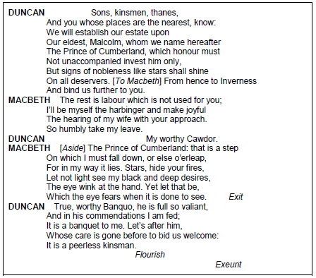

Starting with this speech, explore how Shakespeare presents kingship in Macbeth.
Write about:
- How Shakespeare presents Kingship in this extract
- How Shakespeare presents Kingship in the play as a whole.

Act 1 Scene 5 – Lady Macbeth’s character
Macbeth
Read the following extract from Act 1 Scene 3 of Macbeth and then answer the question that follows.
At this point in the play, Lady Macbeth has just read her husband’s letter telling of the Witches’ prophecy of kingship. She analyses his nature, fearing that he is too decent and squeamish to murder Duncan for the crown.

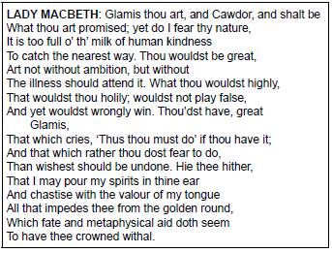
Starting with this speech, explore how Shakespeare presents the character of Lady Macbeth.
Write about:
- How Shakespeare presents the character of Lady Macbeth in this extract
- How Shakespeare presents the character of Lady Macbeth in the play as a whole.

New specification – May 2017 Examination Paper – Act 1 Scene 5 – Ambition
New specification – Specimen Paper One (pre-first examination) – Act 1 Scene 5 – Lady Macbeth as powerful
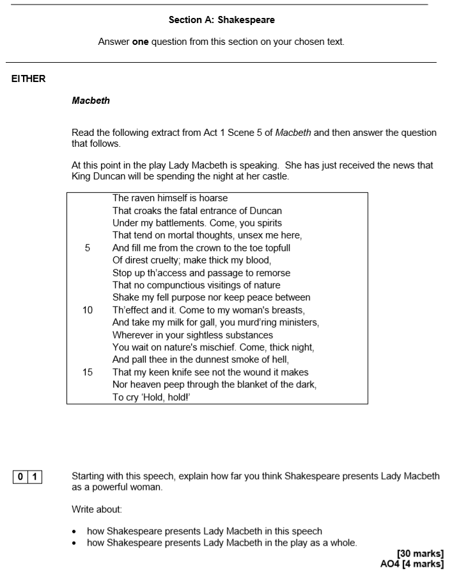

Act 1 Scene 5 – Lady Macbeth’s desire for power
Macbeth
Read the following extract from Act 1 Scene 3 of Macbeth and then answer the question that follows.
At this point in the play, Lady Macbeth casts aside her femininity so that she may have the power to kill King Duncan.

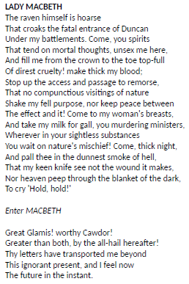
Starting with this speech, explore how Shakespeare presents the desire for power.
Write about:
- How Shakespeare presents the desire for power in this extract
- How Shakespeare presents the desire for power in the play as a whole.

Act 1 Scene 5 – Lady Macbeth’s and Macbeth’s relationship
Macbeth
Read the following extract from Act 1 Scene 3 of Macbeth and then answer the question that follows.
At this point in the play, Lady Macbeth greets Macbeth with thoughts of future greatness. Lady Macbeth urges Macbeth to hide his deadly intentions behind welcoming looks. She will manage the killing of Duncan.

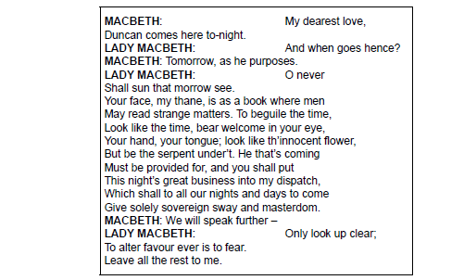

Starting with this speech, explore how Shakespeare presents the relationship of Macbeth and Lady Macbeth
Write about:
- How Shakespeare presents the relationship of Macbeth and Lady Macbeth in this extract.
- How Shakespeare presents the relationship of Macbeth and Lady Macbeth in the play as a whole.

New specification – PiXL 2017 – Act 1 Scene 5 – Appearance and Deceit is a large part of Macbeth’s downfall, to what extent do you agree?

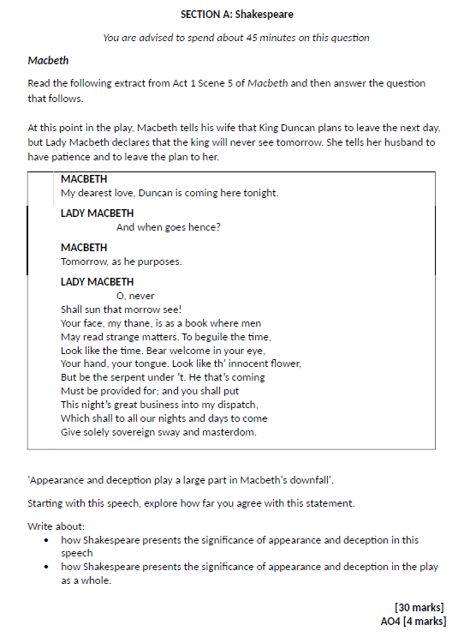
Act 1 Scene 6 – The role of the female
Macbeth
Read the following extract from Act 1 Scene 6 of Macbeth and then answer the question that follows.
At this point in the play, Lady Macbeth welcomes Duncan with elaborate courteous language. She speaks of loyalty, obedience and gratefulness for past honours.

LADY MACBETH
All our service
In every point twice done and then done double
Were poor and single business to contend
Against those honours deep and broad wherewith
Your majesty loads our house: for those of old,
And the late dignities heap'd up to them,
We rest your hermits.
DUNCAN
Where's the thane of Cawdor?
We coursed him at the heels, and had a purpose
To be his purveyor: but he rides well;
And his great love, sharp as his spur, hath holp him
To his home before us. Fair and noble hostess,
We are your guest to-night.
LADY MACBETH
Your servants ever
Have theirs, themselves and what is theirs, in compt,
To make their audit at your highness' pleasure,
Still to return your own.
DUNCAN
Give me your hand;
Conduct me to mine host: we love him highly,
And shall continue our graces towards him.
By your leave, hostess.
Starting with this speech, explore how Shakespeare presents women in Macbeth.
Write about:
- How Shakespeare present Lady Macbeth in this extract
- How Shakespeare presents Lady Macbeth and other women in the play as a whole.
Act 1 Scene 7 – Macbeth
Macbeth
Read the following extract from Act 1 Scene 7 of Macbeth and then answer the question that follows.
At this point in the play, Macbeth struggles with his conscience: killing Duncan will result in vengeance; there are compelling reasons against the murder. Heaven itself will abhor the deed. Only ambition spurs him on.

MACBETH
If it were done when 'tis done, then 'twere well
It were done quickly: if the assassination
Could trammel up the consequence, and catch
With his surcease success; that but this blow
Might be the be-all and the end-all here,
But here, upon this bank and shoal of time,
We'ld jump the life to come. But in these cases
We still have judgment here; that we but teach
Bloody instructions, which, being taught, return
To plague the inventor: this even-handed justice
Commends the ingredients of our poison'd chalice
To our own lips. He's here in double trust;
First, as I am his kinsman and his subject,
Strong both against the deed; then, as his host,
Who should against his murderer shut the door,
Not bear the knife myself. Besides, this Duncan
Hath borne his faculties so meek, hath been
So clear in his great office, that his virtues
Will plead like angels, trumpet-tongued, against
The deep damnation of his taking-off;
And pity, like a naked new-born babe,
Striding the blast, or heaven's cherubim, horsed
Upon the sightless couriers of the air,
Shall blow the horrid deed in every eye,
That tears shall drown the wind. I have no spur
To prick the sides of my intent, but only
Vaulting ambition, which o'erleaps itself
And falls on the other.

Starting with this speech, explore how Shakespeare presents Macbeth’s thoughts and feelings
Write about:
- How Shakespeare present Macbeth’s thoughts and feelings in this speech
- How Shakespeare presents Macbeth’s thoughts and feelings in the play as a whole.
New specification – Specimen Paper Three (2018) – Act 1 Scene 7 – Marriage (Macbeth’s)
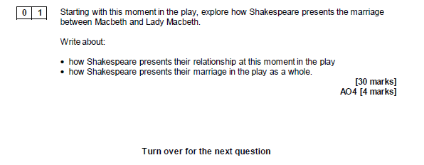

Act 1 Scene 7 – Relationship of Macbeth and Lady Macbeth
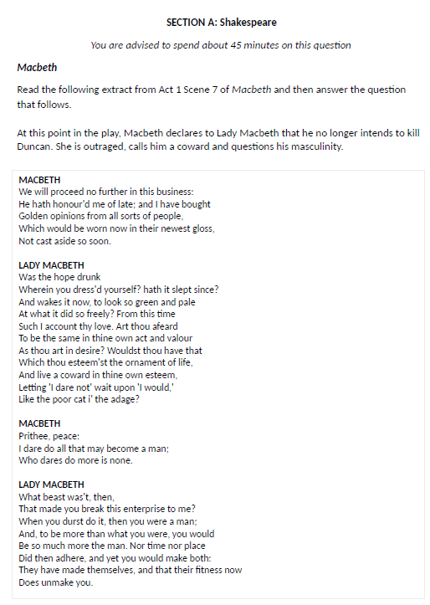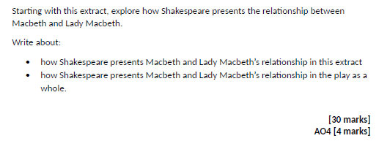
Act 1 Scene 7 – Lady Macbeth as a powerful character

Macbeth
Read the following extract from Act 1 Scene 7 of Macbeth and then answer the question that follows.
At this point in the play, having convinced Macbeth to kill King Duncan tells Macbeth that she will make the king’s bodyguards so drunk that murdering Duncan (and blaming the bodyguards) will be easy. Macbeth applauds her. He says that they should veil their evil designs with pleasant looks.

LADY MACBETH
But screw your courage to the sticking-place,
And we'll not fail. When Duncan is asleep--
Whereto the rather shall his day's hard journey
Soundly invite him--his two chamberlains
Will I with wine and wassail so convince
That memory, the warder of the brain,
Shall be a fume, and the receipt of reason
A limbeck only: when in swinish sleep
Their drenched natures lie as in a death,
What cannot you and I perform upon
The unguarded Duncan? what not put upon
His spongy officers, who shall bear the guilt
Of our great quell?
MACBETH
Bring forth men-children only;
For thy undaunted mettle should compose
Nothing but males. Will it not be received,
When we have mark'd with blood those sleepy two
Of his own chamber and used their very daggers,
That they have done't?
LADY MACBETH
Who dares receive it other,
As we shall make our griefs and clamour roar
Upon his death?
MACBETH
I am settled and bend up
Each corporal agent to this terrible feat.
Away, and mock the time with fairest show:
False face must hide what the false heart doth know.

Starting with this speech, explore how Shakespeare presents Lady Macbeth as a powerful character
Write about:
- How Shakespeare presents Lady Macbeth as powerful in this extract
- How Shakespeare presents Lady Macbeth as powerful in the play as a whole.
Act 2 Scene 1 – Macbeth and Banquo’s friendship

Macbeth
Read the following extract from Act 2 Scene 1 of Macbeth and then answer the question that follows.
At this point in the play, Banquo tells of Duncan’s gratitude for the Macbeths’ hospitality. When Banquo says he has dreamt of the Witches, Macbeth replies with a lie.

BANQUO
What, sir, not yet at rest? The king's a-bed:
He hath been in unusual pleasure, and
Sent forth great largess to your offices.
This diamond he greets your wife withal,
By the name of most kind hostess; and shut up
In measureless content.
MACBETH
Being unprepared,
Our will became the servant to defect;
Which else should free have wrought.
BANQUO
All's well.
I dreamt last night of the three weird sisters:
To you they have show'd some truth.
MACBETH
I think not of them:
Yet, when we can entreat an hour to serve,
We would spend it in some words upon that business,
If you would grant the time.
BANQUO
At your kind'st leisure.
MACBETH
If you shall cleave to my consent, when 'tis,
It shall make honour for you.
BANQUO
So I lose none
In seeking to augment it, but still keep
My bosom franchised and allegiance clear,
I shall be counsell'd.

Starting with this speech, explore how Shakespeare presents Macbeth and Banquo’s friendship
Write about:
- How Shakespeare presents Macbeth and Banquo’s friendship in this extract
- How Shakespeare presents Macbeth and Banquo’s friendship in the play as a whole.

Act 2 Scene 1 – Macbeth as a tragic hero

Macbeth
Read the following extract from Act 2 Scene 1 of Macbeth and then answer the question that follows.
At this point in the play, Macbeth is alone and hallucinates, thinking he sees a blood-stained dagger. As he moves to murder Duncan, his thoughts are filled with evil images.

MACBETH
Is this a dagger which I see before me,
The handle toward my hand? Come, let me clutch thee.
I have thee not, and yet I see thee still.
Art thou not, fatal vision, sensible
To feeling as to sight? or art thou but
A dagger of the mind, a false creation,
Proceeding from the heat-oppressed brain?
I see thee yet, in form as palpable
As this which now I draw.
Thou marshall'st me the way that I was going;
And such an instrument I was to use.
Mine eyes are made the fools o' the other senses,
Or else worth all the rest; I see thee still,
And on thy blade and dudgeon gouts of blood,
Which was not so before. There's no such thing:
It is the bloody business which informs
Thus to mine eyes. Now o'er the one half-world
Nature seems dead, and wicked dreams abuse
The curtain'd sleep; witchcraft celebrates
Pale Hecate's offerings, and wither'd murder,
Alarum'd by his sentinel, the wolf,
Whose howl's his watch, thus with his stealthy pace.
With Tarquin's ravishing strides, towards his design
Moves like a ghost. Thou sure and firm-set earth,
Hear not my steps, which way they walk, for fear
Thy very stones prate of my whereabout,
And take the present horror from the time,
Which now suits with it. Whiles I threat, he lives:
Words to the heat of deeds too cold breath gives.
A bell rings
30
25
20
15
10
5
I go, and it is done; the bell invites me.
Hear it not, Duncan; for it is a knell
That summons thee to heaven or to hell.

Starting with this speech, explore how Shakespeare presents Macbeth as a tragic hero.

Write about:
- How Shakespeare presents Macbeth as a tragic hero in this extract
- How Shakespeare presents Macbeth as a tragic hero in the play as a whole.
January 2012 (higher) – Act 2 Scene 2 – Dramatic and Interesting
At this point in the play, Lady Macbeth, exhilarated by drink, awaits Macbeth’s return from Duncan’s room. She has drugged Duncan’s bodyguards, but fears that the murder has not been done. Macbeth returns and says he has killed the king.
Macbeth
Read the following extract from Act 1 Scene 3 of Macbeth and then answer the question that follows.

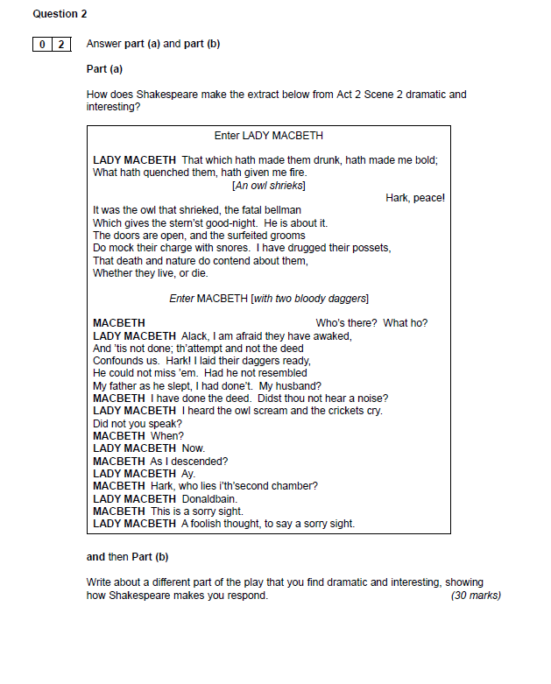

June 2012 (higher) – Act 2, Scene 2 – Lady Macbeth’s and Macbeth’s thoughts and feelings
At this point in the play, Macbeth is obsessed by his inability to say ‘Amen’, and by a voice crying that he has murdered sleep and will never sleep again.
Macbeth
Read the following extract from Act 1 Scene 3 of Macbeth and then answer the question that follows.

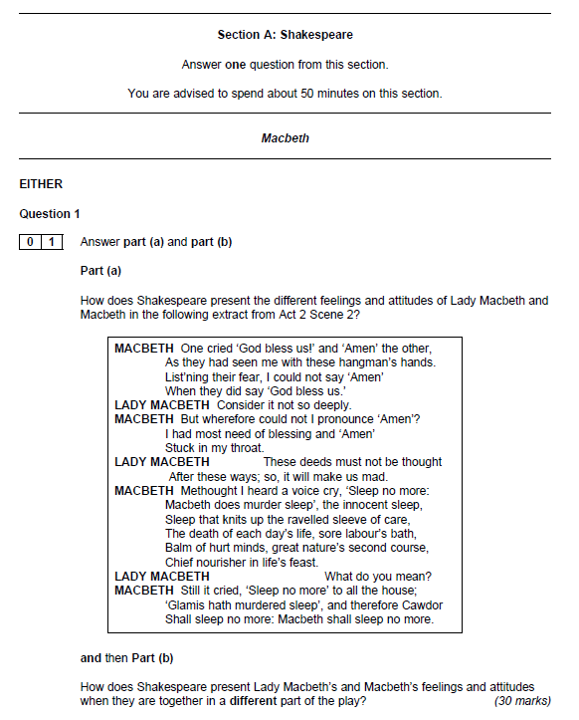

January 2013 (higher) – Act 2, Scene 2 – Lady Macbeth’s feelings
At this point in the play, Macbeth refuses Lady Macbeth’s order to return the daggers. Lady Macbeth takes the daggers to smear Duncan’s blood on his servants’ faces. A knocking sounds frightens Macbeth, but his wife tells him to pull himself together.
Macbeth
Read the following extract from Act 1 Scene 3 of Macbeth and then answer the question that follows.

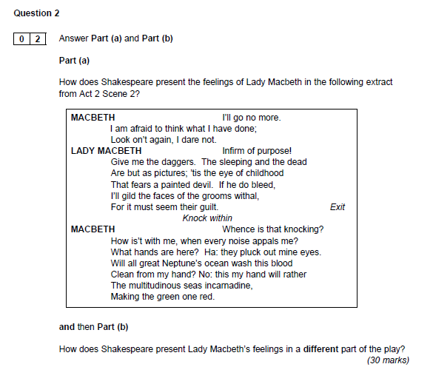

PIXL 2015 – Act 3, Scene 1 – Importance of Banquo

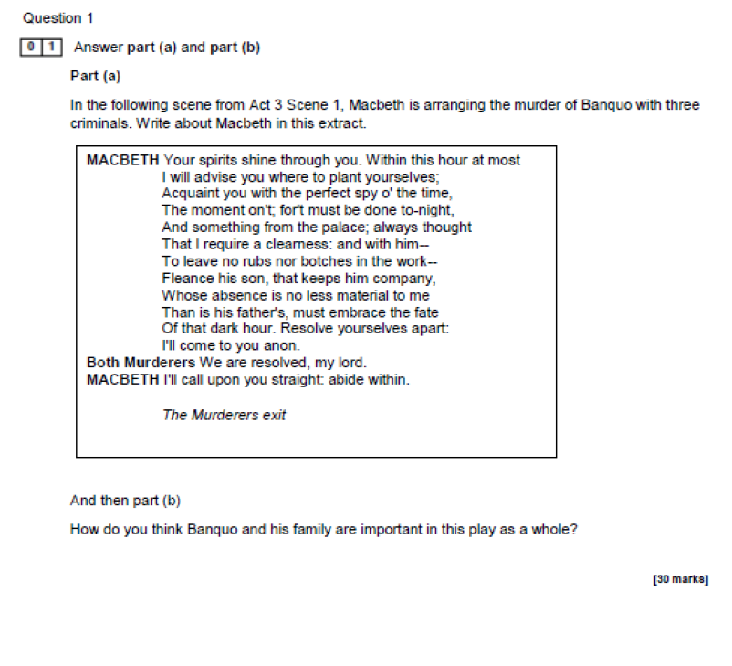

New specification – PiXL 2015 – Act 3, Scene 2 – Paranoia
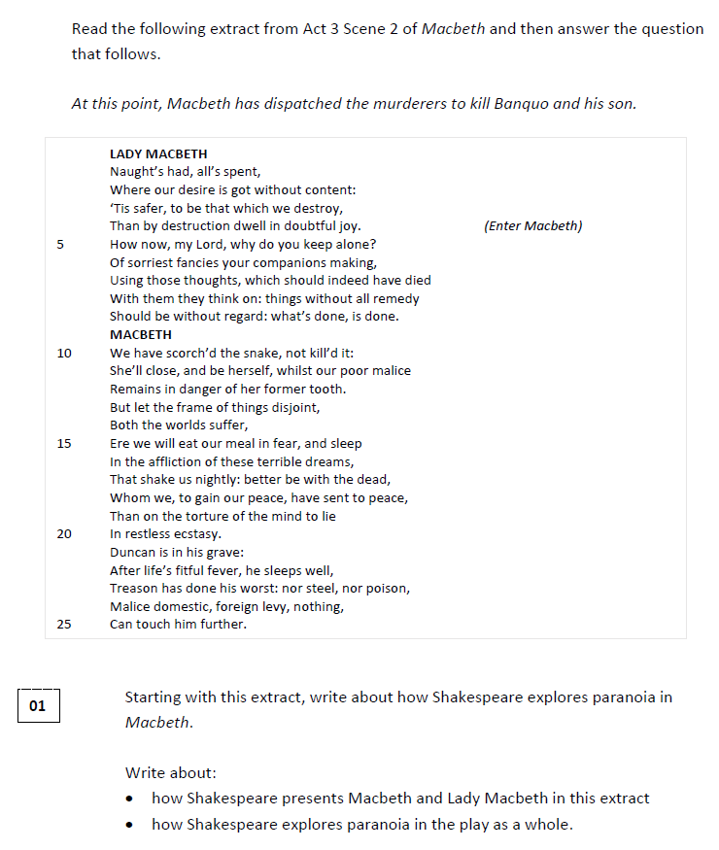

June 2016 (higher) – Act 3, Scene 2 – Relationship between Macbeth and lady Macbeth
At this point in the play, Macbeth tells his wife to pay special regard to Banquo at the Banquo. He speaks contemptuously of having to flatter deceitfully.
Macbeth
Read the following extract from Act 1 Scene 3 of Macbeth and then answer the question that follows.

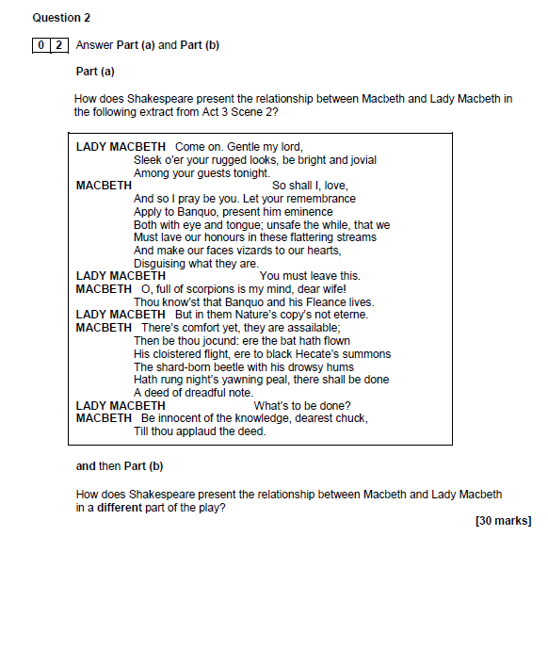

June 2012 (higher) – Act 3, Scene 4 – Dramatic and interesting
At this point in the play, the First Murderer reports Banquo’s death. The news of Fleance’s escape disturbs Macbeth and renews his fears.
Macbeth
Read the following extract from Act 1 Scene 3 of Macbeth and then answer the question that follows.

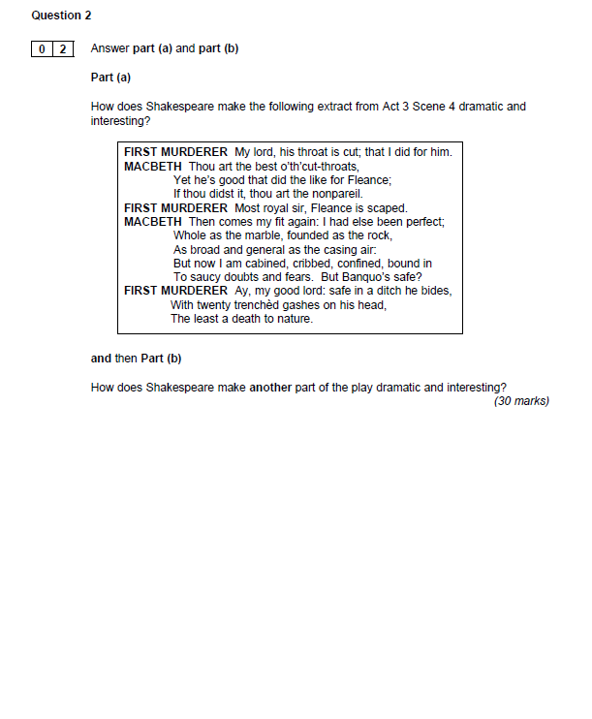

January 2013 (foundation) – Act 3, Scene 4 – Lady Macbeth’s and Macbeth’s feelings
At this point in the play, Lady Macbeth rebukes Macbeth for his display of fear. The Ghost of Banquo leaves. Macbeth broods on how the dead return.
Macbeth
Read the following extract from Act 1 Scene 3 of Macbeth and then answer the question that follows.

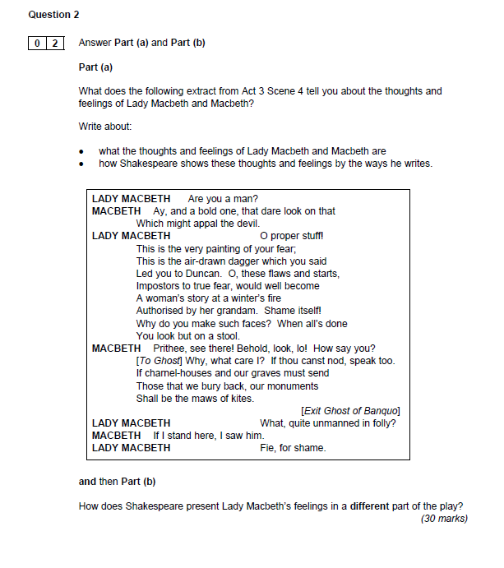

New specification – PiXL 2015 – Act 3, Scene 4 – The Supernatural

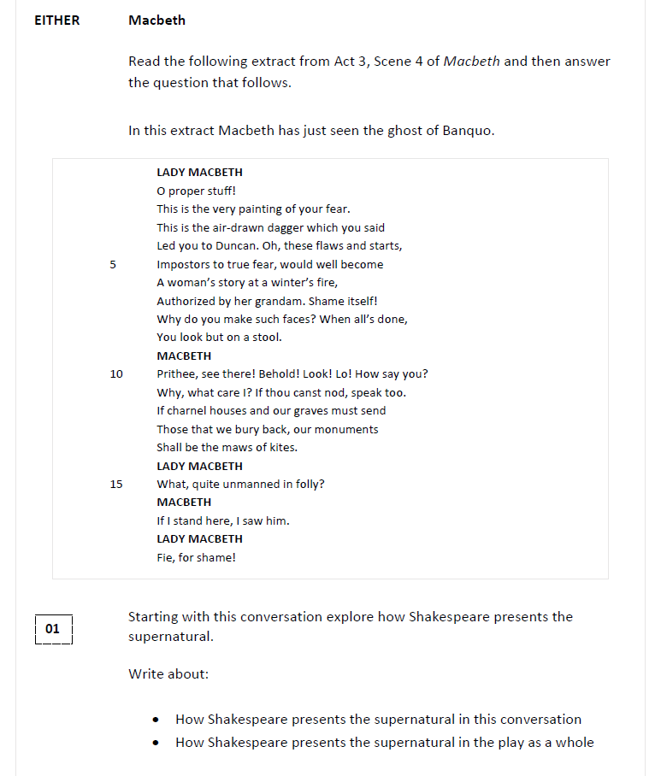

Act 3 Scene 4 – Fear

Macbeth
Read the following extract from Act 3 Scene 4 of Macbeth and then answer the question that follows.
At this point in the play, Macbeth sees Banquo’s ghost for the second time, on seeing the Ghost again, he bursts into violent language, commanding him away.

Re-enter GHOST OF BANQUO
MACBETH
Avaunt! and quit my sight! let the earth hide thee!
Thy bones are marrowless, thy blood is cold;
Thou hast no speculation in those eyes
Which thou dost glare with!
LADY MACBETH
5
Think of this, good peers,
But as a thing of custom: 'tis no other;
Only it spoils the pleasure of the time.
MACBETH
What man dare, I dare:
Approach thou like the rugged Russian bear,
The arm'd rhinoceros, or the Hyrcan tiger;
Take any shape but that, and my firm nerves
Shall never tremble: or be alive again,
And dare me to the desert with thy sword;
If trembling I inhabit then, protest me
The baby of a girl. Hence, horrible shadow!
Unreal mockery, hence!
GHOST OF BANQUO vanishes
10
15
Why, so: being gone,
I am a man again. Pray you, sit still.
LADY MACBETH
You have displaced the mirth, broke the good meeting,
With most admired disorder.
20
MACBETH
Can such things be,
And overcome us like a summer's cloud,
Without our special wonder? You make me strange
Even to the disposition that I owe,
When now I think you can behold such sights,
And keep the natural ruby of your cheeks,
When mine is blanched with fear.
25

Starting with this speech, explore how Shakespeare presents fear.

Write about:
- How Shakespeare presents fear in this extract
- How Shakespeare presents fear in the play as a whole.
June 2015 (higher) – Act 4, Scene 1 – Macbeth and the witches
At this point in the play, Macbeth challenges the Witches to answer what he asks, irrespective of the most appalling consequences.
Macbeth
Read the following extract from Act 1 Scene 3 of Macbeth and then answer the question that follows.

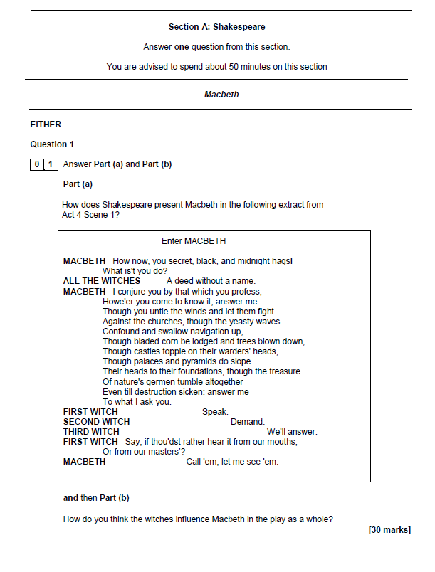
Act 4 Scene 3 – Visual image of chaos and uproar

Macbeth
Read the following extract from Act 4 Scene 3 of Macbeth and then answer the question that follows.
At this point in the play, Macduff condemns Malcolm as unfit to rule. Malcolm says that Macduff’s reaction has removed his suspicions.

MALCOLM
Nay, had I power, I should
Pour the sweet milk of concord into hell,
Uproar the universal peace, confound
All unity on earth.
MACDUFF
5
O Scotland, Scotland!
MALCOLM
If such a one be fit to govern, speak:
I am as I have spoken.
MACDUFF
Fit to govern!
No, not to live. O nation miserable,
With an untitled tyrant bloody-scepter'd,
When shalt thou see thy wholesome days again,
Since that the truest issue of thy throne
By his own interdiction stands accursed,
And does blaspheme his breed? Thy royal father
Was a most sainted king: the queen that bore thee,
Oftener upon her knees than on her feet,
Died every day she lived. Fare thee well!
These evils thou repeat'st upon thyself
Have banish'd me from Scotland. O my breast,
Thy hope ends here!
20
15
10
MALCOLM
Macduff, this noble passion,
Child of integrity, hath from my soul
Wiped the black scruples, reconciled my thoughts
To thy good truth and honour.

Starting with this speech, explore how Shakespeare uses language to create visual imagery of chaos and uproar.

Write about:
- How Shakespeare uses language to create visual imagery of chaos and uproar in this extract
- How Shakespeare uses language to create visual imagery of chaos and uproar in the play as a whole.

June 2014 (higher) – Act 4, Scene 3 – ideas about good and evil
At this point in the play, Macduff cannot hide his grief. He feels that he is too blame for his family’s death. He vows vengeance on Macbeth. Malcolm declares that the time is ripe to overthrow Macbeth, as heaven itself is against him.
Macbeth
Read the following extract from Act 1 Scene 3 of Macbeth and then answer the question that follows.

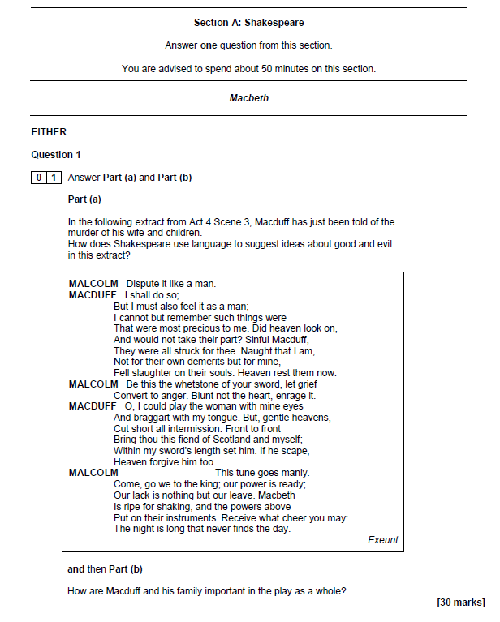

June 2013 (higher) – Act 5, Scene 1 – Lady Macbeth
At this point in the play, Lady Macbeth, fast asleep, tries to wash imagined blood from her hands. Her fragmented language echoes her own and Macbeth’s words about past murders: Duncan, Lady Macduff, Banquo.
Macbeth
Read the following extract from Act 1 Scene 3 of Macbeth and then answer the question that follows.

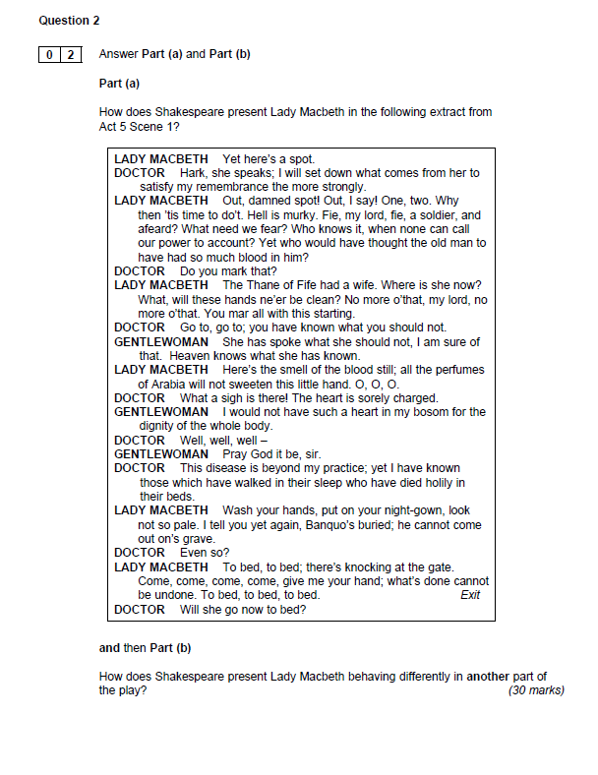
June 2013 (higher) – Act 5, Scene 3 – Macbeth
At this point in the play, Macbeth, receiving news of desertions from his army, recalls the Apparitions’ predictions. He rages at a soldier who tells of Malcolm’s approach.
Macbeth
Read the following extract from Act 1 Scene 3 of Macbeth and then answer the question that follows.

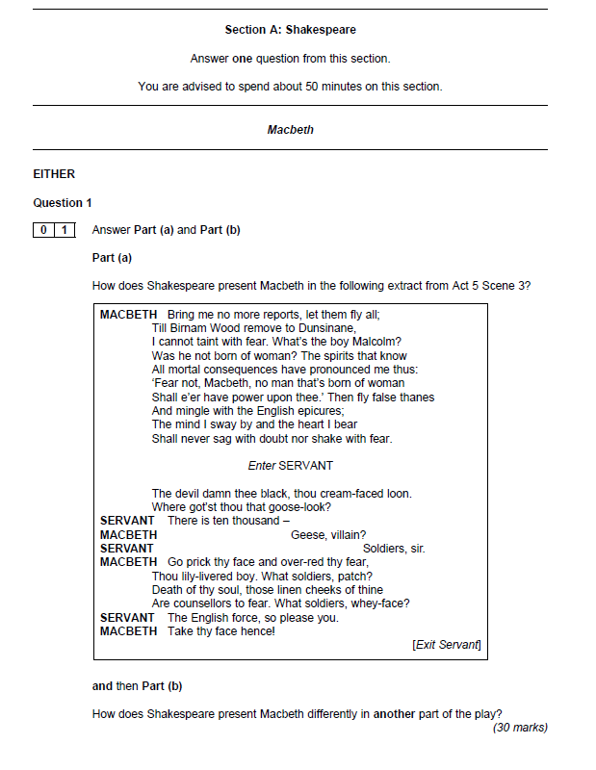

New specification – Specimen Paper Two (pre-first examination) – Act 5, Scene 3 – Macbeth as a hero
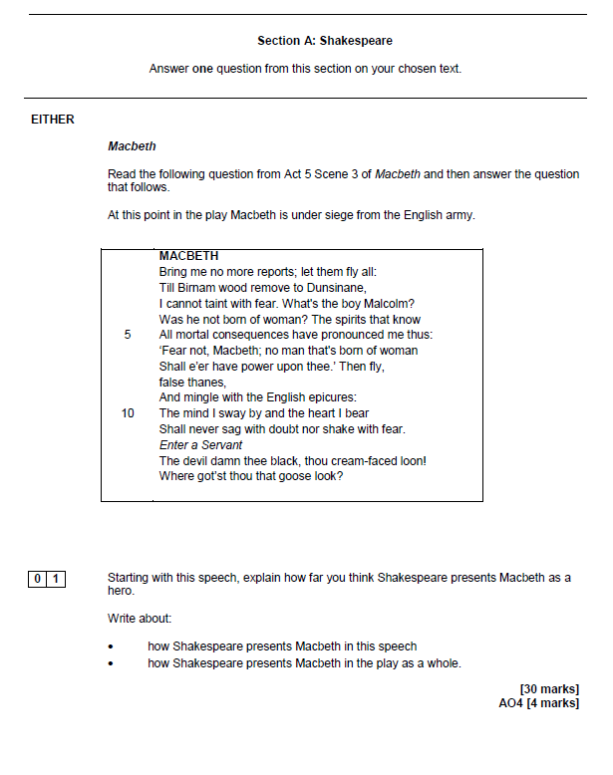

June 2015 (higher) – Act 5, Scene 3 – Macbeth’s state of mind
At this point in the play, Macbeth reflects on a bleak future.
Macbeth
Read the following extract from Act 1 Scene 3 of Macbeth and then answer the question that follows.

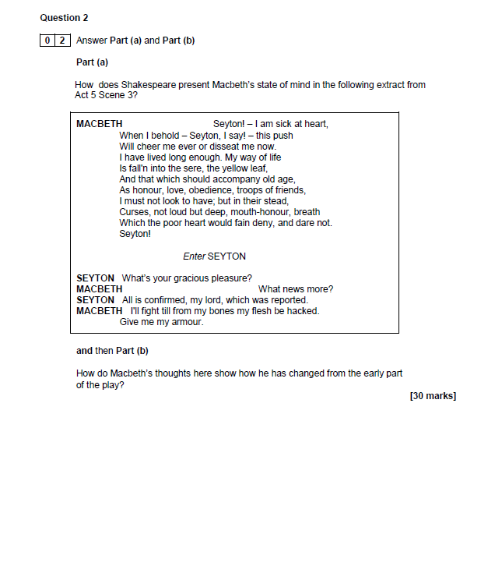

June 2015 (foundation) – Act 5, Scene 3 – Macbeth’s thoughts and feelings
At this point in the play, Macbeth determines to fight to the death, and order rumour-mongers to be killed. When the doctor tells him he cannot cure mental disorders, Macbeth dismisses medicine.
Macbeth
Read the following extract from Act 1 Scene 3 of Macbeth and then answer the question that follows.

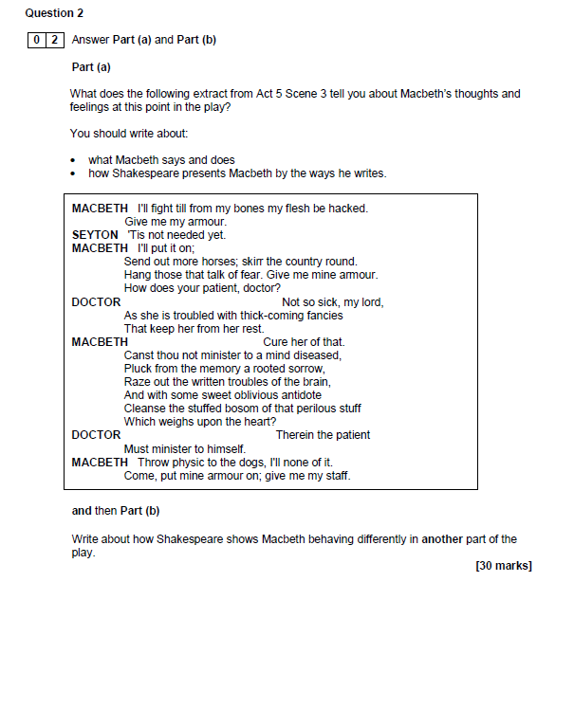

June 2014 (higher) – Act 5, Scene 5 – Macbeth’s state of mind
At this point in the play, Macbeth has almost lost any sense of fear. Seyton brings news of Lady Macbeth’s death. His wife’s death sets Macbeth brooding on life’s futility.
Macbeth
Read the following extract from Act 1 Scene 3 of Macbeth and then answer the question that follows.



