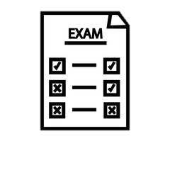
The Passmores Academy Physical Education Journey
BTEC First Level 1-2 Award in Sport Curriculum Map
Your BTEC Sport Journey starts here …
Year
10
Year
11
Unit 6 – Leading Sports Activities
Learners will develop an understanding of the attributes associated with successful sports leadership. Learners will also get the opportunity to plan, lead and review sporting activities.

Unit 2 – Practical Sports Performance - Football
Learners will be able to understand the rules, regulations and scoring systems. In addition to this, learners will be able to practically demonstrate skills, techniques and tactics and be able to review their sports performance. The first part of this Unit will be completed within Football.

BTEC Level 3 in Sport


SCAN HERE to see the BTEC First Level 1-2 Award in Sport specification and the content you will cover in more detail.




Completion of course

Unit 2 – Practical Sports Performance - Badminton
Learners will be able to understand the rules, regulations and scoring systems. In addition to this, learners will be able to practically demonstrate skills, techniques and tactics and be able to review their sports performance. The first part of this unit will be completed within Badminton.


BTEC First Level 1-2 Award in Sport Breakdown

Coursework – 75%
Examination – 25%

Coursework (75%)

For BTEC Sport, you will need to complete various pieces of coursework across Unit 2, 3 & 6. Internal deadlines will be set and must be adhered to throughout your BTEC course.

You will need to submit your coursework on or before the deadline provided. Failure to do this will result in potential jeopardy of your overall grade. Your teacher will deliver the content surrounding your assignment before allowing you time to complete the outlined piece of work.
Examination
The examination element of this BTEC courses refers to Unit 1 – Fitness for Sport and Exercise. The test lasts for 75 minutes and has 60 marks.

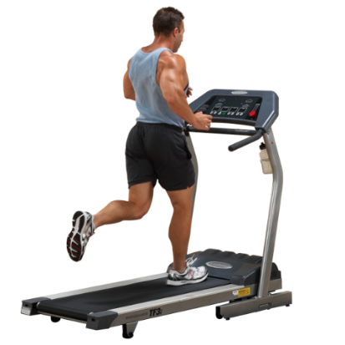

Unit 1 – Fitness for Sport and Exercise
In this Unit, learners will be able to know about the components of fitness and the principles of training, explore the different fitness training methods and investigate how fitness testing helps to determine fitness levels.

Examination (25%)

For Unit 1, you will complete an externally assessed examination. You will get a maximum of two attempts to complete this examination.

Learners will need to know about:
- Know about the components of fitness and the principles of training
- Explore different fitness training methods
- Investigate fitness testing to determine fitness levels.

Scan the QR Code above to find out more information.



Unit 3 – Applying the Principles of Personal Training
Learners will be able to design a personal fitness training programme and know about the musculoskeletal and cardiorespiratory system and the effects on the body during fitness training. Learners will be able to implement and review a self-designed personal fitness training programme to achieve own goals and objectives.

